CRISTIANO MACHADO CESÁRIO

AWARENESS OVER DISTRIBUTED VERSION CONTROL SYSTEMS

Thesis presented to the Computing Graduate program of the Universidade Federal Fluminense in partial fulfillment of the requirements for the degree of Master of Science. Topic Area: Software Engineering.

Advisor: Prof. D.Sc. Leonardo Gresta Paulino Murta

Niterói

2014

Ficha Catalográfica – Esta página deve ser removida na versão a ser entregue para a banca, mas deve ser reinserida na versão final, com a ficha catalográfica fornecida pela biblioteca. Informações sobre este processo devem ser obtidas na secretaria da pós-graduação.

CRISTIANO MACHADO CESÁRIO

AWARENESS OVER DISTRIBUTED VERSION CONTROL SYSTEMS

Thesis presented to the Computing Graduate program of the Universidade Federal Fluminense in partial fulfillment of the requirements for the degree of Master of Science. Topic Area: Software Engineering.

Approved on <MES> <ANO>.

APPROVED BY

\_\_\_\_\_\_\_\_\_\_\_\_\_\_\_\_\_\_\_\_\_\_\_\_\_\_\_\_\_\_\_\_\_\_\_\_\_\_\_\_\_\_\_\_\_\_\_\_\_\_\_\_\_\_\_\_\_\_\_\_\_

Prof. D.Sc. Leonardo Gresta Paulino Murta – Advisor

UFF

\_\_\_\_\_\_\_\_\_\_\_\_\_\_\_\_\_\_\_\_\_\_\_\_\_\_\_\_\_\_\_\_\_\_\_\_\_\_\_\_\_\_\_\_\_\_\_\_\_\_\_\_\_\_\_\_\_\_\_\_\_

Prof. D.Sc. <NOME DO AVALIADOR>

<INSTITUIÇÃO DO AVALIADOR>

\_\_\_\_\_\_\_\_\_\_\_\_\_\_\_\_\_\_\_\_\_\_\_\_\_\_\_\_\_\_\_\_\_\_\_\_\_\_\_\_\_\_\_\_\_\_\_\_\_\_\_\_\_\_\_\_\_\_\_\_\_

Prof. D.Sc. <NOME DO AVALIADOR>

<INSTITUIÇÃO DO AVALIADOR>

Niterói

2014

dedicatória(s): Folha onde o autor presta homenagem ou dedica seu trabalho.

**acknowledgments**

dedicatória(s): Folha onde o autor presta homenagem ou dedica seu trabalho.

dedicatória(s): Folha onde o autor presta homenagem ou dedica seu trabalho.

**Resumo**

O desenvolvimento de software utilizando Sistemas de controle de versão distribuídos tem se tornado cada vez mais frequente recentemente. Tais sistemas trazem mais flexibilidade, mas também trazem uma maior complexidade para administrar e monitorar os múltiplos repositórios existentes, assim como a proliferação de vários ramos. Neste trabalho, propomos o DyeVC, uma abordagem extensível para auxiliar desenvolvedores e administradores de repositórios a identificar dependências entre os repositórios distribuídos, como forma de ajudar a entender o que acontece ao redor do repositório de alguém e descobrir as relações entre os repositórios existentes.

**Palavras-chave: Gerência de configuração, Percepção de espaços de trabalho, Controle de versão distribuído, Evolução de repositórios**

**Abstract**

Software development using distributed version control systems has become more frequent recently. Such systems bring more flexibility, but also bring greater complexity to administer and monitor the multiple existing repositories as well as the proliferation of several branches. In this work we propose DyeVC, an extensible tool to assist developers and repository administrators in identifying dependencies amongst the distributed repositories in order to help to understand what is going on around one’s repository and depict the relations between the existing repositories.

**Keywords: Configuration management, Workspace awareness, Distributed version control, Repository evolution**

**List OF FIGURES**

[Figure 1 - A development scenario involving some developers 17](#_Toc393356493)

[Figure 2 - How DyeVC gathers information 21](#_Toc393356494)

[Figure 3 - Model used to store topology data 22](#_Toc393356495)

[Figure 4 - DyeVC showing notifications in the notification area 23](#_Toc393356496)

[Figure 5 - Topology view for a given project 24](#_Toc393356497)

[Figure 6 - DyeVC Main Screen 24](#_Toc393356498)

[Figure 7 - Commit history for a given project 26](#_Toc393356499)

[Figure 8 - Collapsed commit history 27](#_Toc393356500)

[Figure 9 - Updating repositories in the topology 28](#_Toc393356501)

[Figure 10 - Topology view showing first monitored repository 33](#_Toc393356502)

[Figure 11 - aakoch’s commit history showing commits pending to be pushed 33](#_Toc393356503)

[Figure 12 - Topology view showing the three monitored repositories 33](#_Toc393356504)

[Figure 13 - Adam’s tracked branches 34](#_Toc393356505)

[Figure 14 - Aakoch’s commit history 35](#_Toc393356506)

[Figure 15 - Jeresig’s tracked branches 35](#_Toc393356507)

**List OF TABLES**

[Table 1 - Possible States of a Repository 25](#_Toc393356508)

[Table 2 - Status of a local repository regarding a remote one, based on the existence of non-replicated commits 25](#_Toc393356509)

[Table 3 - Existing commits in each repository 25](#_Toc393356510)

[Table 4 - Status of each repository based on known remote repositories 26](#_Toc393356511)

[Table 5 - Time (in seconds) spent by DyeVC in several operations for repositories with different histories and sizes 37](#_Toc393356512)

[Table 6 - Pearson coefficient between measured operations and repository metrics 37](#_Toc393356513)

**List OF ACRONYMS AND ABBREVIATIONS**

API – Application Programming Interface

CI – Configuration Item

CM – Configuration Management

CVCS – Centralized Version Control System

DAG – Directed Acyclic Graph

DVCS – Distributed Version Control System

JSON – JavaScript Object Notation

RESTful – Representational State Transfer

SCM – Software Configuration Management

VCS – Version Control System

**List of symbols**

Elemento opcional, que deve ser elaborado de acordo com a ordem apresentada no texto, com o devido significado.

TABLE OF CONTENTS

[Chapter 1 – Introduction 14](#_Toc393357579)

[Chapter 2 – Motivation 17](#_Toc393357580)

[Chapter 3 – Awareness over Distributed Version Control Systems 19](#_Toc393357581)

[Chapter 4 – Approach 21](#_Toc393357582)

[4.1 Data Model 21](#_Toc393357583)

[4.2 Levels of Detail 22](#_Toc393357584)

[4.2.1 Level 1: Notifications 23](#_Toc393357585)

[4.2.2 Level 2: Topology 23](#_Toc393357586)

[4.2.3 Level 3: Tracked branches 24](#_Toc393357587)

[4.2.4 Level 4: Commits 26](#_Toc393357588)

[4.3 Behind the Scenes 27](#_Toc393357589)

[Chapter 5 – Implementation 31](#_Toc393357590)

[Chapter 6 – evaluation 32](#_Toc393357591)

[6.1 Analyzing a real project with DyeVC 32](#_Toc393357592)

[6.2 Performance evaluation 36](#_Toc393357593)

[Chapter 7 – Conclusion 39](#_Toc393357594)

[Bibliography 40](#_Toc393357595)

# – Introduction

## Motivation

Version Control Systems (VCS) date back to the 70s, when SCCS emerged (ROCHKIND, 1975). Their primary purpose is to keep software development under control (ESTUBLIER, 2000). Along these almost 40 years, VCSs evolved from a centralized repository with local access, as in SCCS and RCS (TICHY, 1985), to a client-server approach, as in CVS (CEDERQVIST, 2005) and Subversion (COLLINS-SUSSMAN *et al.*, 2011). More recently, distributed VCSs (DVCS) arose, allowing clones of the entire repository in different locations, as in Git (CHACON, 2009) and Mercurial (O’SULLIVAN, 2009b). According to a survey conducted among the Eclipse community (ECLIPSE FOUNDATION, 2013), Git and Github combined usage increased from 6.8% to 36.3% between 2010 and 2013 (a growth greater than 600%). During this same period, Subversion and CVS combined usage decreased from 71% in 2010 to 42.3% in 2013. This clearly shows momentum and a strong tendency in the adoption of DVCSs among the open source community.

Besides these changes from local to client-server and then to distributed architecture, the concurrency control policy adopted by VCSs also changed from lock-based (pessimistic) to branch-based (optimistic). According with Walrad and Strom (WALRAD; STROM, 2002), creating branches in VCSs is essential to software development because it enables concurrent development, allowing the maintenance of different versions of a system in parallel, the customization to different platforms and to different customers, among other features that are expected by current software development teams. DVCS include better support to work with branches (O’SULLIVAN, 2009a), turning the branch creation into a recurring pattern, no matter if this creation is explicitly done by executing a “*branch*” command or implicitly, when a repository is cloned. All these branches, whether explicit or not, will eventually be reintegrated by means of merge operations, reflecting to the main development line the changes made.

However, distributed software development, especially from the geographical perspective (GUMM, 2006), brings a set of risk factors, and Configuration Management is affected by them (BATTIN *et al.*, 2001). The increasing growth of development teams, and their distribution along distant locations – even different continents – together with the proliferation of branches, introduce additional complexity for perceiving actions performed in parallel by different developers. According to Perry *et al.* (PERRY *et al.*, 1998), concurrent development increases the number of defects in software. Besides, Silva *et al.* (DA SILVA *et al.*, 2006) say that branches are frequently used for promoting isolation amongst developers. This postpones the perception of conflicts that result from changes made by co-workers. These conflicts are noticed only after a pull or a push in the context of DVCS. Moreover, Brun *et al.* (BRUN *et al.*, 2011) show that, even using modern DVCSs, conflicts during *merges* are frequent, persistent, and appear not only as overlapping textual edits (i.e., physical conflicts) but also as subsequent build (i.e., syntactic conflicts) and test failures (i.e., semantic conflicts).

By enabling repository clones, DVCS expand the branching possibilities discussed by Appleton *et al.* (APPLETON *et al.*, 1998), allowing several repositories to coexist with fragments of the project history. This may lead to complex topologies where changes can be sent to or received from any repository. This scenario generates traffic similar to that of peer-to-peer applications. In practice, projects impose some restrictions over this topology freedom. However, it can be still much more complex than the traditional client-server topology found in Centralized Version Control Systems (CVCS).

To illustrate this situation, Figure 1 shows a scenario with some developers, each one owning a clone of the repository originally created at Xavier Institute. Xavier Institute acts like a central repository, where code developed by all teams is integrated, tested, and released to production. There is a team working at Xavier Institute, led by Professor Xavier, and a remote developer (Storm) that periodically receives updates from the Institute. Outside the Institute, Wolverine leads a remote team located in a different site, which is constantly synchronized with the Institute. Solid lines in Figure 1 indicate data being pushed, whereas dotted lines indicate data being pulled. Thus, for example, Rogue can both pull updates from Gambit and push updates to him, and Beast can only pull updates from Rogue.



Figure 1 - A development scenario involving some developers

Each one of the developers has a complete copy of the repository. Luckily, this scenario has a Configuration Management (CM) Plan in action, otherwise any one would be able to send and receive updates to or from each other, leading to a total of $n∙\left(n-1\right)$ different possibilities of communication (where n is the number of developers in the topology). In practice, this limit is usually not reached: while interaction amongst some developers is frequent, it may happen that others have no idea about the existence of some coworkers. It occurs with Mystique and Nightcrawler, for example, where there is no direct communication.

As an example, from a developer’s point of view, like Beast, how can he know at a given moment if there are commits in Rogue, in Gambit, or in Nightcrawler clones that were not pulled yet? Alternatively, would be the case that there are local commits pending to be pushed to Gambit? Beast could certainly periodically pull changes from his peers, checking if there were updates available, but this would be a manual procedure, prone to be forgotten. It would be more practical if Beast could have an up to date knowledge of his peers, warning him about any local or remote updates that had not been synchronized yet.

On the other hand, from an administrator’s point of view, how can she know the existing clones of a project and how they relate among each other? How can she know if there are pending commits to be sent from a staging repository to a production one? This kind of perception regarding others work is known as “awareness”, which is defined by (DOURISH; BELLOTTI, 1992) as “an understanding of the activities of others to provide a context for one’s own activities”.

Most of the existing approaches that deal with providing awareness of concurrent work (in different clones or different branches) are focused only in CVCSs, which are much less prone to branches if compared to DVCSs. Other approaches focus on DVCSs, but looking at a specific branch and without offering a way to discover dependencies between clones (i.e., peers), or changes introduced in different branches of work.

Therefore, this work main motivation is to establish an extensible platform that helps DVCS administrators and users in understanding who the existing peers are and how they relate with each other.

## Goals

In this work, we propose a novel visualization infrastructure for DVCS, which gathers information about different clones of a repository and presents them visually to the user, allowing one to perceive how his repository evolved over time and how this evolution compares to the evolution of other repositories in the project.

Thus, this work proposes an extensible platform that enables repository administrators to visualize which the existing repositories of a project are and how they interact with each other. Having this information is important to verify if communication is taking place accordingly, based on what was defined in the CM Plan.

This work also aims at increasing the developer knowledge of what is going on around his repository and the repositories of his teammates, despite the branch where changes are being done.

## Research Questions

Our approach and its evaluation have the primarily objective to answer the following questions:

* Q1: Which clones were created from a repository?
* Q2: What are the dependencies between different clones?
* Q3: Which changes are under work in parallel (in different clones or different branches) and which of them are available to be incorporated into my work?
* Q4: Is it computationally feasible to gather this information from all known repositories, keeping them available to be used when needed?

## Contributions

This work introduces a new infrastructure for DVCS monitoring and awareness that can gather information from DVCS repositories, consolidate this information and provide a series of extensible visualizations to the user. These visualizations can help administrators and developers in knowing who the participating peers in a project are and how they depend upon each other. The infrastructure also opens new research possibilities to enhance the existing visualizations and provide new ones. The information that is gathered can be increased and used to mine information in the repositories and thus uncovering usage patterns or presenting metrics.

## Organization

Besides this introduction, this work is organized in four other chapters. <Chapter 2> presents some introductory topics regarding DVCS. It contrasts DVCS usage against CVCS. It also explains the concept of *branches* and how they are used in DVCS. Lastly, it presents the related work, which include commit visualization approaches, approaches that provide awareness of concurrent changes, and approaches that focus on repository visualization.

<Chapter 3> presents the approach, named DyeVC[[1]](#footnote-1). This chapter describes how DVCS information is gathered and structured. Then it outlines the existing visualizations in a hierarchical way, discussing the level of detail included in each one, over the example introduced in Figure 1. It also discusses the algorithm used in information gathering, which is in the heart of the process that discovers related peers, dependencies, and work in progress. Furthermore, it presents the technologies used in the implementation. Finally, it shows a typical usage scenario of DyeVC, describing its prototype and the first steps needed to use it.

<Chapter 4> describes the evaluation performed on the usage of DyeVC to provide awareness over an open source project that uses DVCS. Next, the scalability of the approach is evaluated, presenting the factors that may affect the capability of using DyeVC. Lastly, it presents some threats to the validity of the performed evaluation.

Finally, <Chapter 5> concludes this work, presenting contributions, limitations, and future work.

# – Awareness over Distributed Version Control Systems

## Introduction

SCM is part of the Software Engineering and was born in the 70s (ESTUBLIER, 2000). According to (2006), under the development perspective, SCM is divided into three main systems: Change Management, Version Control, and Release Management. **Change Management** is in charge of systematically controlling the configuration, storing and reporting the information produced along the change requests. **Version Control** deals with the identification and evolution of configuration items (CI). Finally, **Release Management** automates the process of building executable files from the source code and releasing them into production.

Version Control Systems (VCSs) date back to the 70s, when the first VCS, called Source Code Control System (SCCS), emerged (ROCHKIND, 1975). VCSs were the first SCM systems to emerge and, since then, they have evolved substantially, from the local access needed by SCCS, to a client-server architecture, and more recently to a distributed architecture. Besides their original scope, they have also been used as a data source to mine data related to software development, because they have the knowledge of all CIs and how they evolved over time (what was changed, why changes occurred, when changes happened, and who performed the changes). Moreover, as VCSs are the single point where every IC resides, they might be used not only to know what happened in the past, but also provide awareness of what is happening in the present and to help predicting what might happen in the future.

Awareness is defined by DOURISH and BELLOTTI (1992) as “an understanding of the activities of others to provide a context for one’s own activities”. The information needed to provide awareness depends on what people need to be aware of. In the context of this work, which focus on the awareness of changes occurring in DVCS, all the information needed is generally available within the repository, such as which files have changed, what changes were applied, who applied the changes, when the changes occurred, and why the changes were applied.

This chapter presents some basic concepts related to DVCS and some approaches related to providing awareness combined with VCS. Section 1.2 discusses central concepts regarding how DVCS work. Section 1.3 presents related work. Finally, Section 1.4 presents the final considerations of this chapter.

## Distributed Version Control Systems

CVCS relies on a centralized repository, stored on a server (Figure 1.a). When someone wants to work on any CI, a *checkout* is performed, copying a specific version of the artifacts from the repository to a workspace where changes can be applied. Later, after applying the changes, a *commit* (also known as *check-in)* is performed, sending all the changes back to the repository. Updates made by other developers can be brought to the workspace at any time, by performing an *update*. Updates are automatically merged into workspace, or, in the case of physical conflicts (same part of the artifact changed locally and remotely), the developer might have to handle the merge manually.

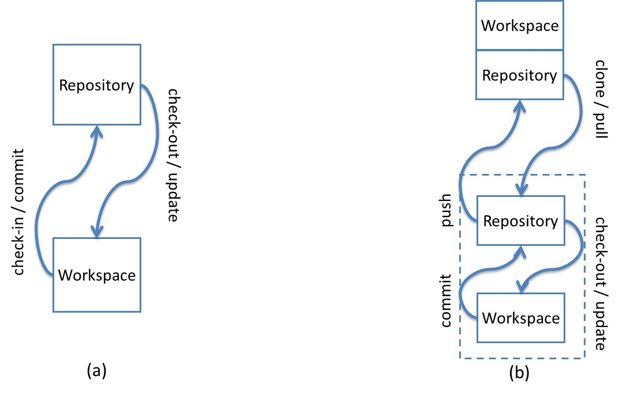

Figure 1 – CVCS (a) versus DVCS (b)

DVCS, on the other hand, does not rely on a centralized repository. It uses an architecture where the entire repository is distributed and exists in every machine where someone wants to work with it. The changes continue to take place on a workspace, but there is a local copy of the repository attached to the workspace (Figure 1.b). The main operations (*checkout, commit*,and *update*)continue to exist, but are performed locally, allowing offline work, committing whenever necessary. However, another set of commands arises, which allows sending and receiving changes between different repositories. Initially, a *clone* is performed, copying the repository from a specified location. The copy can be done from a repository located on a partner or on a server. We will refer to the original repository as *remote repository*.There is no concept of a *central* repository, but some repository may act as a central repository by having, for example, a strict policy regarding who might send changes to it. Repositories might either have an associated workspace or not. A repository located on a server, where local changes are not expected to occur, does not need to have a workspace associated, and is referred as a *bare* repository. A *bare* repository is just like a regular one, except that it does not have a workspace associated with it. Due to the lack of a workspace associated, commands that depend upon a workspace (*commit, update,* and *merge*) cannot be performed on a *bare* repository.Changes can be sent from a local repository to a remote repository by invoking a *push* command. Changes can be received from remote repositories and applied immediately to the workspace, leading to merges / conflicts, or they can stay at the local repository to be applied later. A *pull* command brings the changes and applies them to the workspace. A *pull* can be broken into two subcommands[[2]](#footnote-2): a *fetch* command, that only transfers the changes to the local repository, without applying them to the workspace, and a *merge* command, which applies the changes to the workspace.

## Branching in DVCS

The commits performed in a repository are based on previous commits, thus forming a directed acyclic graph (DAG), where newer commits point to older commits. Figure 2 represents a repository with three commits. Commit “3” is pointed by a label named *master*. As new commits arise, the *master* pointer moves accordingly. This way, if we want to refer to the last commit in this repository, we do not need to know how many commits there are. All we have to do is ask for the *master* commit.

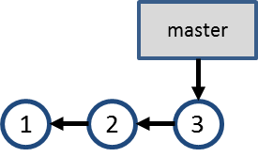

Figure 2 – Commits in a repository

This linear development is not frequent in real repositories, for a number of reasons, such as supporting multiple releases of the same software, trying new technologies that might be included in future versions or fixing multiple bugs in parallel[[3]](#footnote-3). In such cases, it is common use *branches*, which are, according to LEON (2004), “a deviation from the main development line for an item”.

Suppose that a bug is found in a software product during tests. The test team creates issue 55, asking the development team to fix the bug. The development team verifies that the software version being tested corresponds to commit #3, but the bug will take a considerable time to be fixed and the development cannot stop waiting for the bug fix. A branch named “issue55” is then created, pointing to commit #3 (Figure 3.a). At this moment, development can occur in parallel, with commits #5 and #7 being made to branch “issue55” and commits #4 and #6 being made to branch “master” (Figure 3.b). Finally, the team decides to merge the fix to issue #55 into the “master” branch, generating commit #8 (Figure 3.c).

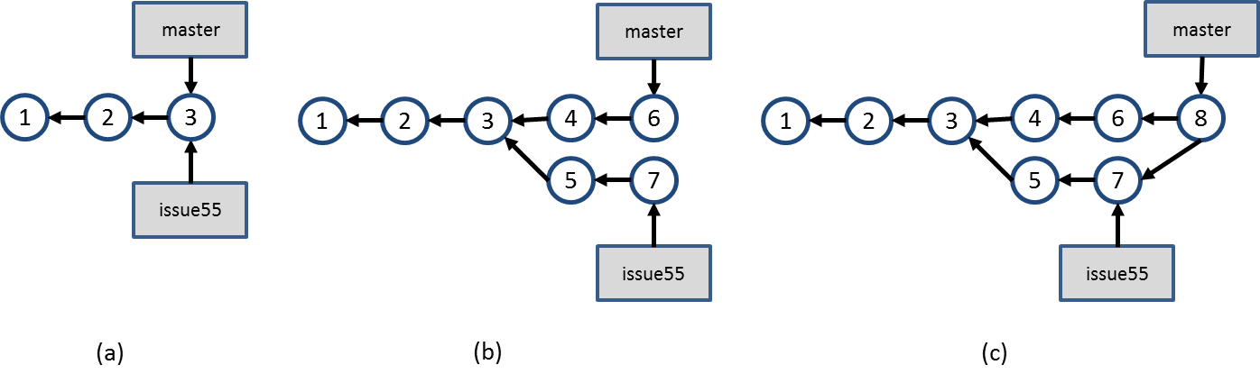

Figure 3 – Branch “issue55” is created and development occurs in parallel

This is a scenario where we experience the usage of *explicit branches*, i.e., a scenario where one explicitly creates a branch to perform some work. However, when using DVCS, there are other situations where branches arise implicitly. In these situations, one does not explicitly asks to create a new branch, but the branch concept is used anyway. We refer to branches that are no created explicitly as *implicit branches*. The next sections will show some situations where this occurs.

### Cloning a repository

Suppose a repository like the one shown in Figure 2. At this point, clones A, B, and C are created by different developers, as shown in Figure 4, where the first three commits are the same in all of them, but other As discussed in Section 1.2, each clone is a complete repository copy, independent from the other clones, enabling parallel development. We thus can see each clone as a fork of the original repository. The colors in the commits are used to identify the clone where that commit was originally done. The numbers identifying each commit are used for the sake of this example, but commits are not necessarily identified by a sequential number. For example, in Git, commits are identified by a hash code of 40 hexadecimal digits.

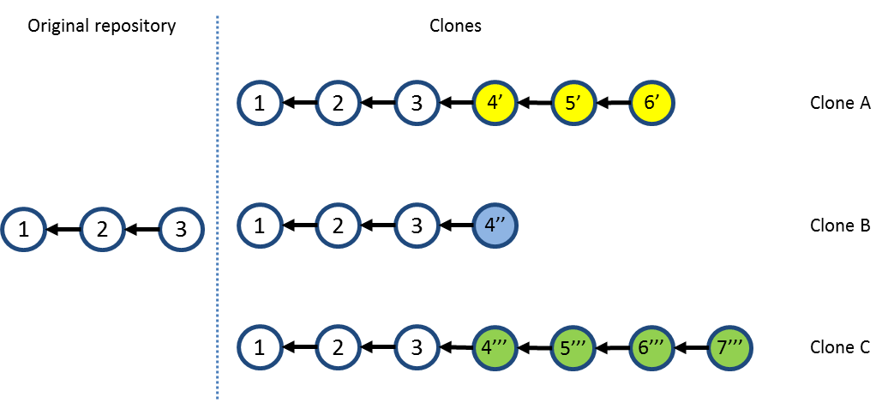

Figure 4 – Branching through cloning

The first clone to push changes to the original repository is able to do it with no extra work. Let us assume that clone A is the first one to push its changes to the original repository. This results in a scenario like the one shown in Figure 5.

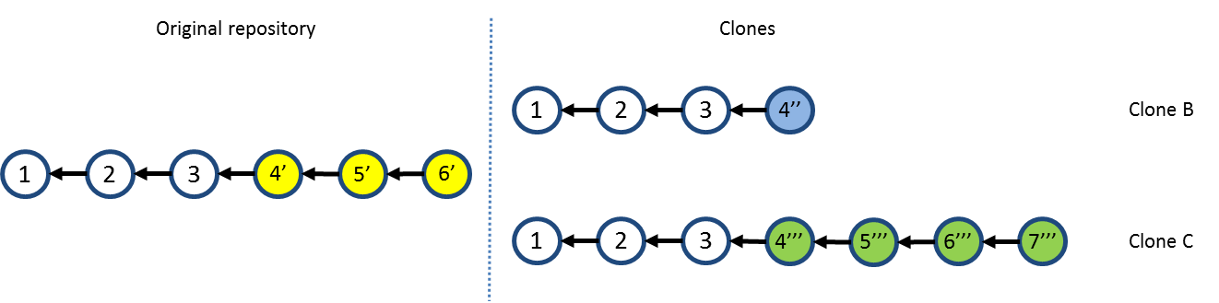

Figure 5 – Repositories after pushing changes from clone A

Next, clone B tries to push its changes to the original repository, but this not allowed, because it could result in inconsistencies in the VCS, once commits from clone A were never tested together with commits from clone B. To allow clone B to push its changes, it is necessary to first pull commits 4’, 5’ and 6’ from the original repository, merging them into the clone B workspace, resulting in the scenario shown in Figure 6. Notice that, in this case, there is an additional commit, denoted by 5’’.

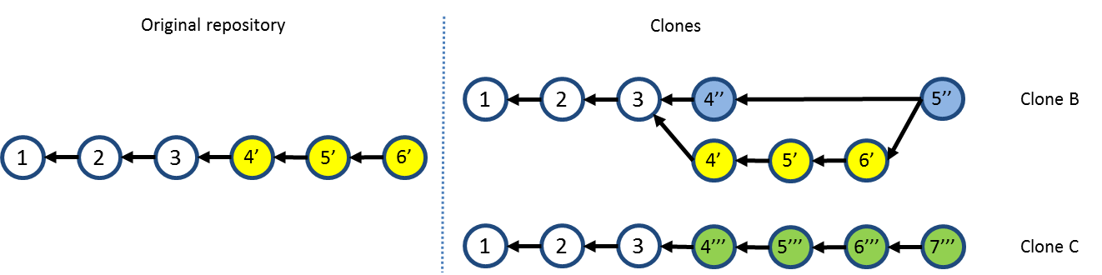

Figure 6 – Repositories after merging work from clone B.

Clone B then push its changes, resulting in the scenario shown in Figure 7. Finally, clone C has to follow the same procedure, i.e., pull the changes previously pushed by clone A and clone B, and merge them into its workspace, resulting in the scenario shown in Figure 8.

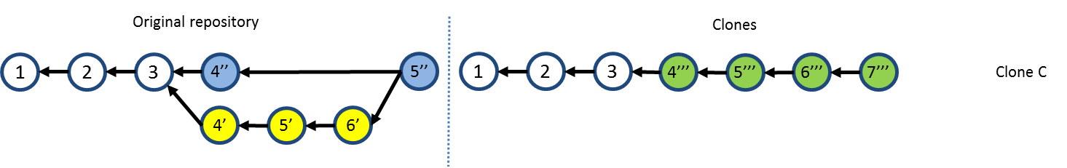

Figure 7 – Repositories after pushing changes from clone B

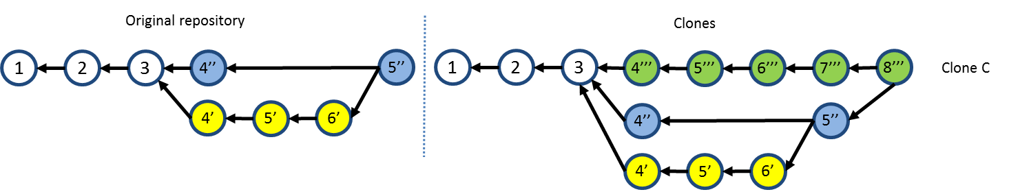

Figure 8 – Repositories after merging work from clone C

### Fetching from a remote repository

In the previous section, before pushing changes to a repository that has received pushes from other peers, we explained that one should pull the recent changes, merging them into his workspace. However, one could choose to bring the changes without immediately merging them. This is accomplished by only fetching the updates. If clone B had opted to only fetch updates from the original repository, this would result in a branch, as shown in Figure 9. Here, branch *master* is the local branch in clone B, and branch *origin/master* is the master branch from the original repository.

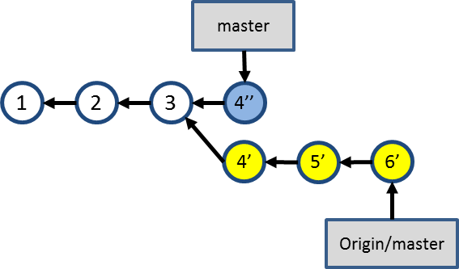

Figure 9 – Branch after fetching updates from the original repository

This brings new concept regarding branches: *tracking* and *non-tracking* branches. A non-tracking branch is a local branch that is not shared with peers. A non-tracked branch exists only in the local repository and it is not pushed to remote repositories. On the other hand, a tracking branch is a branch that one chooses to share with peers, by associating a local branch with a branch in the remote repository. In the example shown in Figure 9, we say that local branch *master* tracks branch *master* in the remote repository. This way, when one pushes to a remote repository, the remote branches are updated to point to the correct commits. The result is shown in Figure 10. Notice that both the local and the remote branches are updated to point to same commit.

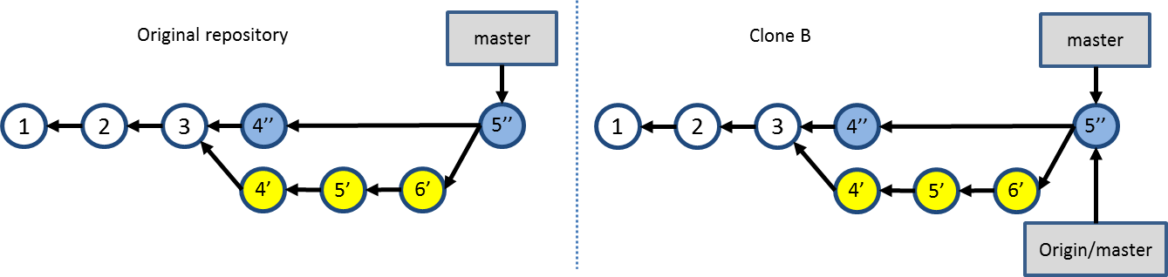

Figure 10 – Result of pushing changes from a tracked branch.

### Anonymous branches

An anonymous branch is a branch created when we checkout a commit which is not referenced by a branch. When this happens, commits are performed in the same way, pointing to their predecessors, with the difference that there is no branch pointing to them (see Figure 11). This way, if one chooses to work with another branch after committing on an anonymous branch, these commits will be accessible only through their internal identifications generated by the VCS.

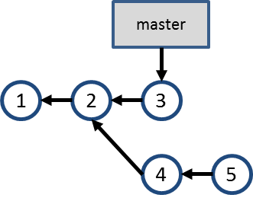

Figure 11 – Anonymous branch

## Related Work

According to (DIEHL, 2007), software visualization can be separated into three aspects: structure, behavior, and evolution. DyeVC relates primarily with the evolution aspect, more specifically with studies that aim at improving the awareness for people that work with distributed software development. A recent work by (STEINMACHER *et al.*, 2012) presents a systematic review of awareness studies and classify them according to the Awareness Framework (GUTWIN *et al.*, 1996) and according to the 3C Collaboration Model (FUKS *et al.*, 2007). The classification is not exclusive, i.e., a given tool can present elements of different awareness types. According to (GUTWIN *et al.*, 1996), DyeVC can be classified as a “Workspace Awareness” approach and according to (FUKS *et al.*, 2007), DyeVC fits into the “Coordination” and “Cooperation” categories.

This section describes some approaches related to awareness or visualization of information stored in VCSs. We used a criterion similar to snowballing sample (GOODMAN, 1961) to select the approaches, starting with a finite individual population as a seed and looking for these approaches’ citations and at approaches that cited them. Our initial seed was based on the referenced papers analyzed by (STEINMACHER *et al.*, 2012). We also searched at the main academic digital libraries (ACM, IEEE, SpringerLink and ScienceDirect) and at the industry, using the keywords “revision”, “source code”, “software configuration”, “source control”, “version control”, “application” and “system”, combined with “awareness” and “visualization”. We filtered the results found to get only studies that used VCS. The resulting studies were divided into three groups. The first group includes tools that notify commit activities. The second group comprises approaches that give the developer awareness of concurrent changes, sometimes informing them if conflicts were detected. Finally, the third group includes approaches that visualize repository information in a linear way. The next sub-sections discuss each of these groups.

### Commit Notification

Under the “Commit Notification” group, we found approaches such as *SVN Notifier*[[4]](#footnote-4), *SCM Notifier*[[5]](#footnote-5), *Commit Monitor*[[6]](#footnote-6), *SVN Radar*[[7]](#footnote-7), *Hg Commit Monitor*[[8]](#footnote-8)and Elvin (FITZPATRICK *et al.*, 2006)*.* The primary focus of these approaches is on increasing the developer’s perception of concurrent work by showing notifications whenever other developers perform actions. Figure 2 shows some of these approaches in action. We can see notifications shown by *SVN Notifier* (Figure 2.a), *SCM Notifier* (Figure 2.b), *Commit Monitor* (Figure 2.c) and *Elvin* (Figure 2.d).

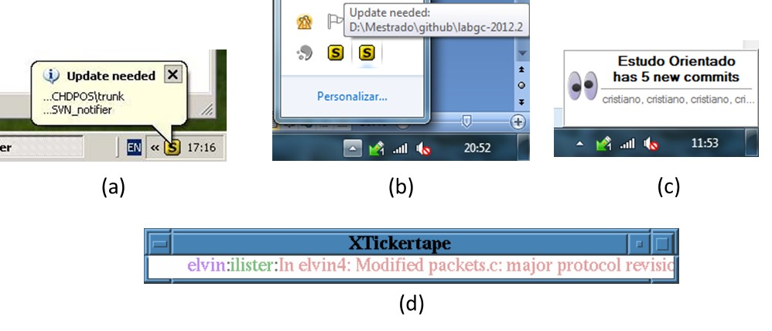

Figure 12 – Commit Notification Approaches

### Awareness of Concurrent Changes

There are many approaches that propose increasing the awareness of changes across different team members. *Palantir* (SARMA *et al.*, 2012) shares information about changes to the same files across different workspaces, showing this information as an eclipse plugin, as shown in Figure 3. The plugin shows the percentage of modification of each file, such as [S:24] in Payment.java, which indicates that 24% of the file was modified. It also indicates if there is a direct conflict (marked in the top left with a blue triangle) or an indirect conflict (red triangle in the top right). Direct conflicts are those that occur when there are changes on the same line in different workspaces. Indirect conflicts are those that occur in different lines, for example, when someone changes the signature of a method and the call to that method is not changed to incorporate the change.



Figure 13 – Eclipse window with Palantir plugin. Extracted from (SARMA *et al.*, 2012)

*CollabVS* (DEWAN; HEGDE, 2007) is a Visual Studio plugin that identifies conflicts while code is being edited (Figure 4.a). The author can choose between just adding a watch to be notified when his collaborator finishes editing the conflicting code (Figure 4.b) and establishing a communication session with the other author (Figure 4.c).



**(a)**

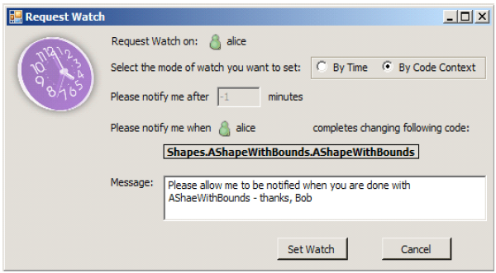

**(b) (c)**

Figure 14 – CollabVS snippets. Extracted from (DEWAN; HEGDE, 2007)

*FASTDash* (BIEHL *et al.*, 2007) does not detect conflicts directly, but provides awareness of potential conflicts, such as two programmers editing the same region of the same source file (direct conflicts), in repositories stored in Team Foundation Server[[9]](#footnote-9). The notifications can be presented in a visualization runtime as a plugin to Visual Studio. Figure 5 shows *FASTDash* Visualization Runtime. According to the authors, *FASTDash* was designed for agile project teams of 3-8 developers, which makes it inappropriate to be used in large projects.



Figure 15 – FASTDash Visualization Runtime. Extracted from (BIEHL *et al.*, 2007)

*Lighthouse* (DA SILVA *et al.*, 2006) is an Eclipse plug-in that monitors workspaces for changes as soon as they are made, in order to address conflicts sooner. It presents an up to date design (Figure 6) indicating where the changes have been made and by whom, as well as if these changes have already been propagated to the repository and to other workspaces.



Figure 16 – Lighthouse plugin on Eclipse. Extracted from (DA SILVA et al., 2006)

*WeCode* (GUIMARÃES; SILVA, 2012) is an eclipse plugin for real-time integration of changes, which is accomplished by means of continuously merging work done by other team members. Figure 7 shows the plugin in action. The Team view (3) shows the members of the team, along with their changes. The Team Merge view (4) shows the conflicts that arise during continuous merge. The Package Explorer (1) and the Source Code view (2) were adapted to indicate existing conflicts.

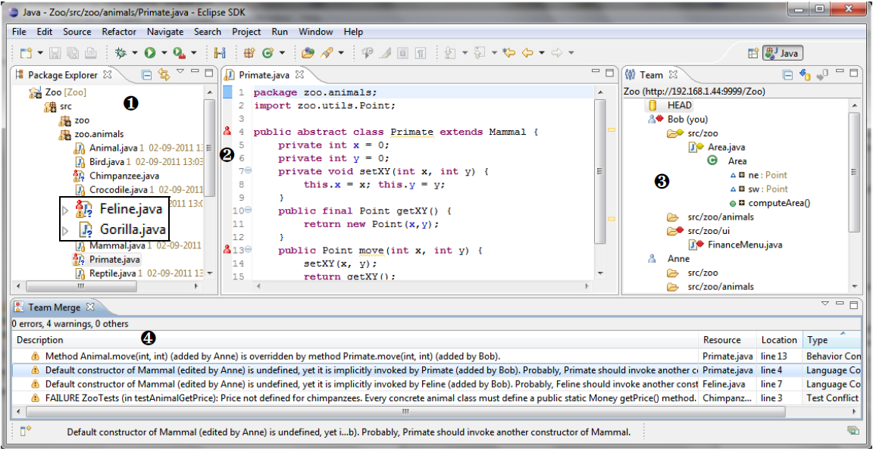

Figure 17 – WeCode continuous merging. Extracted from (GUIMARÃES; SILVA, 2012)

*Crystal* (BRUN *et al.*, 2011) performs background merges between pairs of repositories, compiling and testing the merged code, resulting in “merge failure”, “compilation failure”, “tests failure”, or “tests passed” (Figure 8).



Figure 18 – Crystal snapshot. Extracted from (BRUN et al., 2011)

### Repository Visualization

Repository visualization consists in taking the information stored in VCSs and present it in a visual way. A number of approaches exist that propose different visualizations with different focuses. *Gevol* focuses on program structures. It extracts information about a Java program stored in a CVS version control system and displays it using a temporal graph visualizer. Figure 9 shows an example of a call graph, where nodes start out red, and in the case that no changes exist they turn purple and then blue. When a change is performed, the affected nodes turn red and the cycle starts again.

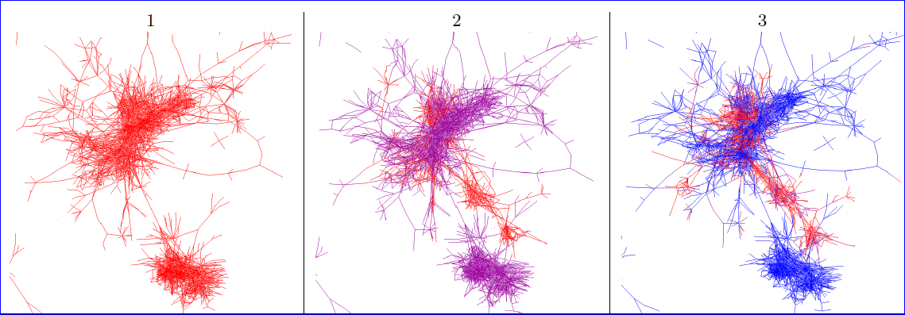

Figure 19 – Gevol: focus on program structures. Extracted from (COLLBERG et al., 2003)

*The Evolution Matrix* (LANZA, 2001) focuses on classes and their evolution within a software system. Figure 10 shows a snapshot of the approach. The columns represent different versions of the software and the rows represent different classes. The size of the lines represent the size of the classes. This way, it is possible to see if the system is growing, shrinking or becoming stagnated.

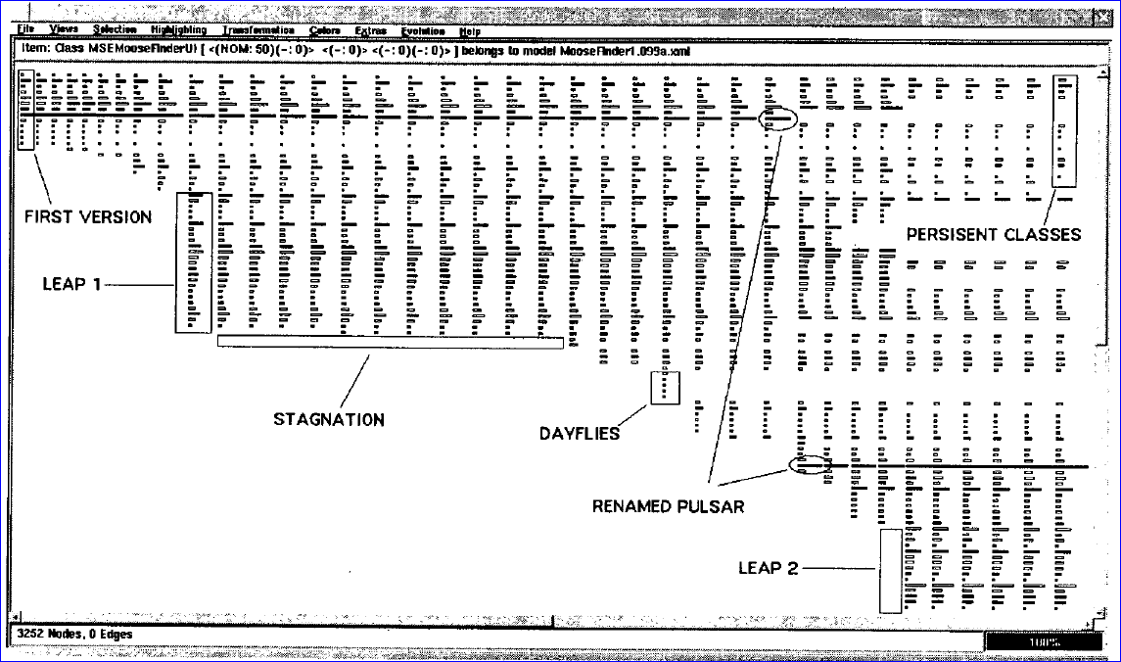

Figure 20 - The Evolution Matrix: focus on classes. Extracted from (LANZA, 2001)

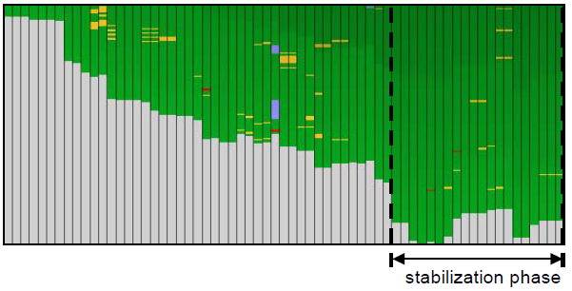

Figure 21 – CVSScan: focus on lines. Extracted from (VOINEA *et al.*, 2005)

*CVSScan* (VOINEA *et al.*, 2005) is a line-oriented approach that shows how a given file changed over the time, through different versions. Figure 11 shows a snapshot of the approach for a file. Each column represents a version and the rows represent lines of the file. The color scheme indicates if the line is the same (green), inserted (blue), deleted (red), or modified (yellow). Different color schemes can be chosen to depict, for example, the author of the last change in each line or the type of construct that the line represents (file reference, block, or comment).

*Lifesource* (GILBERT; KARAHALIOS, 2006) focus on showing how authors are contributing to a project. Figure 12 shows a visualization named *CodeSaw*, which shows the contributions along one year. Each colored line represents a different author and has two axes: the upper axis represents code contributions and the lower axis represents e-mail contributions to project mailing list.

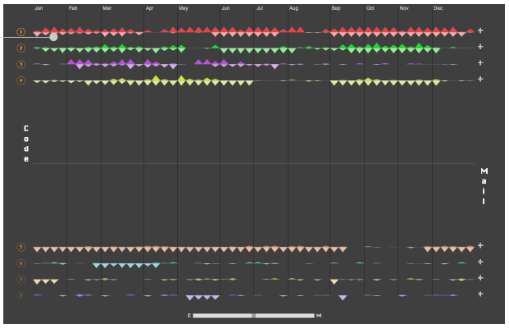

Figure 22 – LifeSource: focus on authors. Extracted from (GILBERT; KARAHALIOS, 2006)

*VisGi* (ELSEN, 2013), *Visugit* (HOZUMI, 2010), and *GitHub’s Network Graph* (PRESTON-WERNER, 2008) were designed to incorporate information about the different branches of a repository, using graphs to render the information. Figure 13 shows three different repositories represented by *VisGi*, which uses a horizontal layout that represents time in a left-right direction. *VisGi* shows branches as solid black dots and branches intersections as dark gray dots.

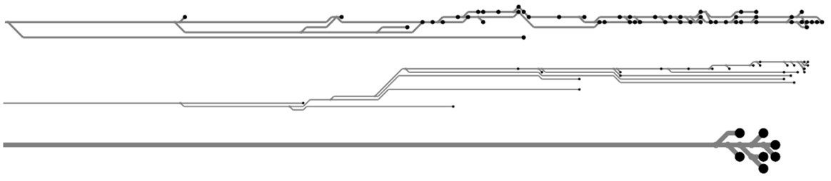

Figure 23 – VisGi: focus on branches. Extracted from (ELSEN, 2013)

Figure 14 shows a snapshot of *Visugit*, which shows the commits in a repository, depicting the existing branches (e.g., github/master and master).

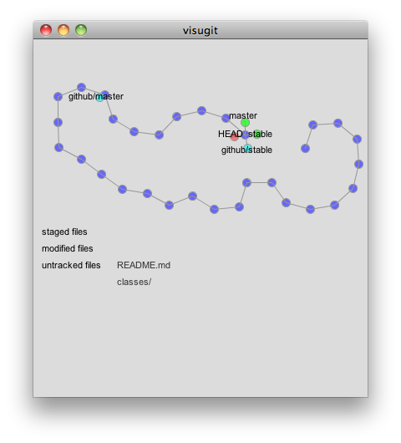

Figure 24 – Visugit: focus on branches. Extracted from (HOZUMI, 2010)

Figure 15 shows *GitHub’s Network Graph,* which shows all the commits associated with a repository, along with the information about branches (shown in the tag markers). The graph is drawn from the perspective of a given user (which is called *root user* – in this case, *mojombo*) and all the commits that exist in *mojombo’s* repository are drawn across his name. For other users, commits that exist in their repositories but not in *mojombo’s* are drawn across their names.

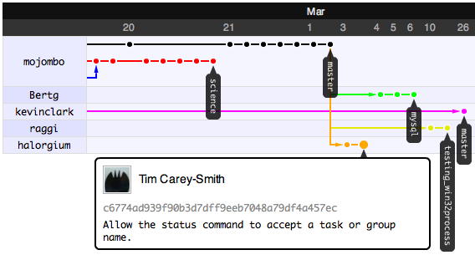

Figure 25 - GitHub’s Network Graph: focus on branches. Extracted from (PRESTON-WERNER, 2008)

## Final Considerations

This chapter presented some core concepts regarding DVCS, which are essential to understand the remaining of this work. We also presented three groups of approaches related with this work.

The first group shows notifications whenever actions are performed by other developers. The approaches shown in this group do not identify related repositories and do not provide information in different levels of details, such as status, branches, and commits.

The second group comprises approaches that propose to increase the awareness of changes across different team members. Among these studies, only *Crystal* and *FASTDash* work with DVCSs, but none of them deals with repositories that pull updates from more than one peer*.*

In the third group, we have a number of approaches that focus on repository visualization. Most of these works were applied only to CVCSs. The only exception found were (ELSEN, 2013; HOZUMI, 2010) and (PRESTON-WERNER, 2008), which work with Git repositories, but look only at a local repository, not showing, for example, where a given commit can be found. At first sight, the work of PRESTON-WERNER seems to address this topic, but it actually shows commits that a peer has and the root user does not, but a given commit could not exist in the root user and exist in other repositories, which we cannot depict in their visualization.

Lastly, it is worth noticing that we could not find any similar work showing the dependencies among several clones of a DVCS.

# – Approach

## Introduction

As we have discussed in <link to chapter on related work>, DVCSs lead to a number of repository copies that may communicate with each other, receiving or sending updates. This operating mode resembles a peer-to-peer network topology (SCHOLLMEIER, 2001), where there are processing units and the flows between them through predefined connection paths. Whereas there are several approaches to discover such network topologies (DONG; GANG, 2012; LI, H. *et al.*, 2009; LI, M. *et al.*, 2013; UZAIR *et al.*, 2007; YAN, 2012; YONG *et al.*, 2010), to number a few, there is no correspondent approach that deals with DVCS, as discussed in <link to chapter on related work>.

Consider the example scenario shown in Figure 1, where there are some developers, each one owning a clone of a repository originally created at Xavier Institute. Xavier Institute acts like a central repository, where code developed by all teams is integrated, tested, and released to production. There is a team working at Xavier Institute, led by Professor Xavier, and a remote freelancer developer (Storm) that periodically receives updates from the Institute. Outside the Institute, Wolverine leads a remote team located in a different site, which is constantly synchronized with the Institute. Solid lines in Figure 1 indicate push operations whereas dotted lines indicate pull operations (See Section <link to section on DVCS concepts>. Thus, for example, Rogue can both pull updates from Gambit and push updates to him, and Beast can only pull updates from Rogue.

Each one of the developers has a complete copy of the repository. Luckily, this scenario has a Configuration Management Plan (IEEE, 2012) in action, otherwise each one would be able to send and receive updates to or from any other, leading to a total of *n \* (n - 1)* different possibilities of communication (where *n* is the number of developers in the topology). In practice, however, this limit is not reached: while interaction amongst some developers is frequent, it may happen that others have no idea about the existence of some coworkers. For instance, Mystique and Nightcrawler may not be aware of each other existence, as there is no direct communication between them.



Figure 1 - A development scenario involving some developers

Apart from drawing a topology, several questions may arise from this scenario. As an example, from a developer’s point of view, like Beast, how can he know at a given moment if there are commits in Rogue, in Gambit, or in Nightcrawler clones that were not yet pulled? Alternatively, would be the case that there are local commits pending to be pushed to Gambit? Beast could certainly periodically pull changes from his peers, checking if there were updates available, but this would be a manual procedure, prone to be forgotten. What if there had the knowledge of Beast’s peers, and constantly monitored those, warning Beast of any local or remote updates that had not been synchronized yet?

From an administrator’s point of view, how can he know which the existing clones of a project are and how they relate amongst each other? How can he know if there are pending commits to be send from a staging repository to a production one?

The DyeVC approach (CESARIO; MURTA, 2013) came to fill this gap in supporting DVCS usage. The goal of DyeVC is three-fold. First, DyeVC should work as a non-obtrusive awareness tool to increase the developer knowledge on what is going on around his repository and the repositories of his teammates. Second, DyeVC should enable repository administrators and/or managers to visualize how the several existing repositories of a project interact with each other. Third, DyeVC should establish an extensible platform to present different information and metrics regarding projects that use DVCS.

This chapter explains the DyeVC approach, which consists of: (1) a mechanism to gather information from a set of repositories and (2) a set of extensible views with different levels of detail, allowing DyeVC users to visualize this information.

This chapter is organized as follows: Section 1.2 explains the data model used to store the information that our approach gathers. Section 1.3 shows how this information is presented using different levels of detail. Section 1.4 discusses what happens behind the scenes, presenting the algorithms involved in the data synchronization process. Section 1.5 presents the technologies used in the prototype implementation. Section 1.6 discusses DyeVC usage. Lastly, Section 1.7 presents the final considerations of this chapter.

## Information Gathering

DyeVC continuously gathers information from a group of interrelated repositories, starting from repositories registered by the user. As shown in Figure 2, data is gathered by DyeVC instances running at each user machine and is stored in a central document database. This way, information from one DyeVC instance is made available to every other instance in the topology. It is important to notice that DyeVC does not change anything in the local repositories. The approach only reads information in the repositories, and all the work is done at the central database or in working copies of the local repositories.

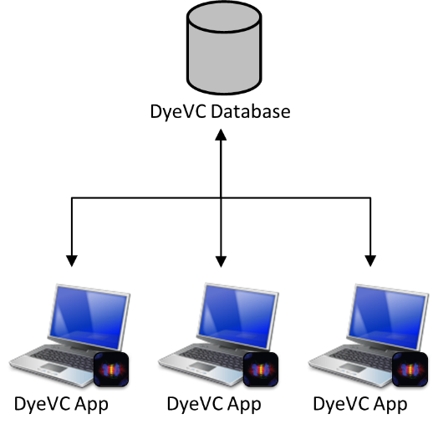

Figure 2 - How DyeVC gathers information

The data stored at the central database follows the model presented in Figure 3. A Project is used to group all repository clones of the same system, and each project is identified by a project name. Repositories are stored as RepositoryInfo and are identified by an id and the user can give it a meaningful clone name. We also store the hostname where the repository resides, as well as its path (e.g., a folder name, if it is on local disk or a URL if it is on remote server. A RepositoryInfo also has a list of clones to which it pushes to and a list of clones from which it pulls. These lists are represented respectively by the self-associations pushesTo and pullsFrom. Finally, we store the list of DyeVC instances that monitor the repository, in order to remove from the topology the repositories that are no longer referenced.

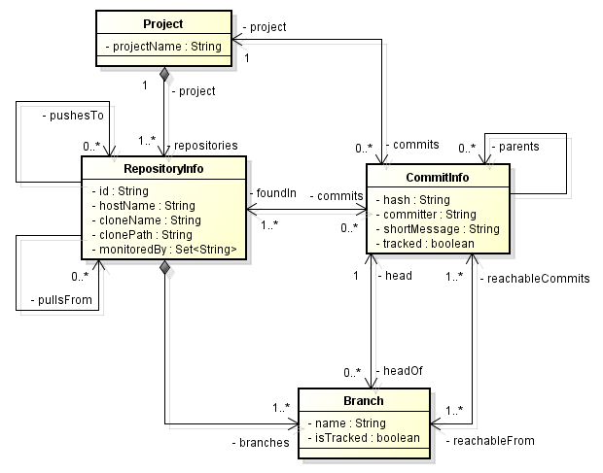

Figure 3 - Model used to store topology data

The finer grain of information is the CommitInfo, which represents each commit in the topology. A commit is identified by a hash code and it can refer to its parents, in the case of a merge. As each commit may not exist in all repositories of the topology, we store the list of repositories where each commit can be found (foundIn association). We also store the committer, the commit message, and the information whether the commits belongs to tracked branches or to non-tracked branches.

The last element in Figure 3 is the Branch. Branches are part of a RepositoryInfo. A Branch instance has a name and a boolean attribute *isTracked*, which is true if the branch tracks a remote branch. A RepositoryInfo may have one or many branches (it must have at least one branch, which is the *main* one). A Branch has two associations with CommitInfo: through the first association, a Branch knows which commit is its head and, conversely, a commit knows which branches point to it as a head. The second association represents which commits are reachable from a given branch and, conversely, the branches from which the commit is reachable.

DyeVC can gather information not only from repositories registered on a DyeVC instance running on the user’s machine, but also from their peers (which are the repositories that a given repository communicates), even when these peers do not have a DyeVC instance running locally. As there is a communication path between a registered repository and its peers (in order to push and pull data), we are able to analyze the commits that exist in these peers. This allow us to visualize the entire topology and to know where each commit exists, even in peers where DyeVC is not running, provided that these peers communicate somehow with a peer running DyeVC. Details on how data is gathered are explained in Section 1.4.

## Information Visualization

The visualization of information gathered by DyeVC is divided into four different levels of detail: Level 1 presents high-level notifications about the registered repositories. Level 2 present the whole topology of a given project. Level 3 zooms into the branches of the repository, to see the status of each local branch that tracks a remote branch. Lastly, Level 4 zooms into the commits of the repository, to see a visual log with information about each commit. The following sections discuss each of these levels.

### Level 1: Notifications

In Level 1, our approach presents notifications whenever a change is detected in any registered repository or in any of their peers. The notifications are presented in the system notification area, in a non-obtrusive way, allowing the user to begin investigating what is occurring, if desired. Figure 4 shows an example of this kind of notification. In this example, it is possible to observe that …

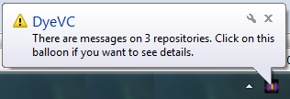

Figure 4 - DyeVC showing notifications in the notification area

### Level 2: Topology

In Level 2, we present a topology view showing all repositories for a given project, as depicted, where each node represents a known clone of the project DyeVC, at a given moment. The current user clone is highlighted as a blue computer and other clones are presented as black computers. Servers represent repositories that do not pull from nor push to any other clone (probably central repositories) or clones where DyeVC is not running. The reason why the representation is the same for both kinds of nodes is that, once DyeVC is not running at a given clone, we cannot infer if the clone pushes to or pulls from anyone. Thus, it will have empty push and pull lists and will be understood as a central repository.

Each edge in the graph represents a relationship between two repositories. Edges with a continuous stroke mean that the source clone pushes to the destination clone. Edges with a dotted stroke mean that the destination clone pulls from the source clone. The edge labels show two numbers separated by a dash. The first number represents how many commits in tracked branches from the source clone are missing in the destination clone. The second number represents how many commits in non-tracked branches from the source clone are missing in the destination clone. The edge colors are used to represent the synchronization status: green edges mean that both clones are synchronized (i.e., both clones have the same set of commits), whereas red edges mean that the pair is not synchronized.

For example, it is possible to observe in Figure 5 that …

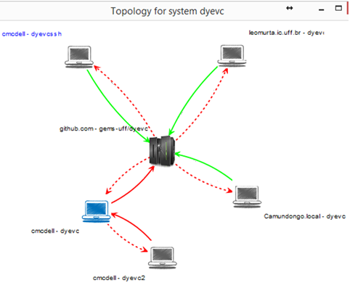

Figure 5 - Topology view of DyeVC project, at a given moment

### Level 3: Tracked branches

Level 3 information is presented at Figure 6 and it allows one to depict the status of each tracked branch between registered repositories and their peers. This information is complemented with that of Level 4, shown in the next section.

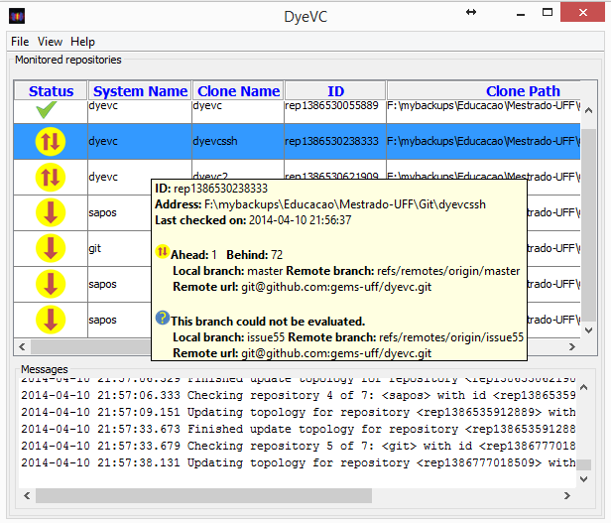

Figure 6 - DyeVC Main Screen

The status evaluation considers the existing commits in each repository individually. Table 1 shows the possible states presented by DyeVC. Due to the nature of DVCS, old data is never deleted and commits are cumulative. Thus, if a commit N is created over a commit N – 1, the existence of commit N in a given repository implies that commit N – 1 also exists in the repository. With that said, by checking the existence of commits in the local repository not yet replicated to the remote repository, and vice-versa, it is possible to come up with one of the situations presented in Table 2.

Table 1 - Possible States of a Repository

|  |  |
| --- | --- |
| Status | Description |
| question_32 | DyeVC has **not analyzed** the repository yet. |
| check_32 | Repository is **synchronized** with all peers. |
| ahead_ylw_32 | Repository has changes that were not sent yet to its peers (it is **ahead** its peers). |
| behind_ylw_32 | Peers have changes that were not sent yet to the repository (it is **behind** its peers). |
| aheadbehind_ylw_32 | Repository is both **ahead and behind** its peers. |
| nocheck_32 | **Invalid** repository. This happens when DyeVC cannot access the repository. The reason is presented to the user. |

Table 2 - Status of a local repository regarding a remote one, based on the existence of non-replicated commits

| Existence of  non-replicated commits | | Local Status |
| --- | --- | --- |
| Local  Repository | Remote  Repository |
| Yes | Yes | aheadbehind_ylw_32Ahead and Behind (needs *pull* and *push*) |
| Yes | No | ahead_ylw_32Ahead (needs *push*) |
| No | Yes | behind_ylw_32Behind (needs *pull*) |
| No | No | check_32Synchronized |

To illustrate how this approach works, let us assume that each commit is represented by an integer number and take the right portion of Figure 1, which represents developers led by Wolverine. This scenario is shown in Figure 7.

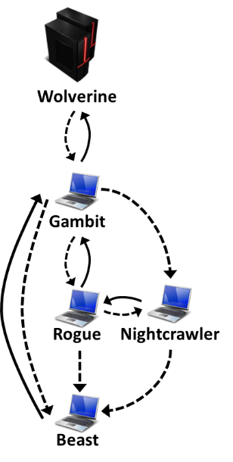

Figure 7 – Developers led by Wolverine

At a giving moment, the local repositories of each developer have the commits shown in Table 3.

Table 3 - Existing commits in each repository

|  |  |  |  |  |  |
| --- | --- | --- | --- | --- | --- |
| Repository | Wolverine | Gambit | Rogue | Nightcrawler | Beast |
| Commits | 10  11 | 10  11 | 10  12 | 10  11  13 | 10 |

Considering just the synchronization paths presented in Figure 7, which depend on the direction of the arrows and on the type of the lines, the perception of each developer regarding his known peers is shown in Table 4. Notice that the perceptions are not symmetric. For instance, as Gambit does not pull updates from Nightcrawler, there is no sense in giving him information regarding Nightcrawler.

Table 4 - Status of each repository based on known remote repositories

|  |  |  |  |  |  |
| --- | --- | --- | --- | --- | --- |
| Repository | Wolverine | Gambit | Rogue | Nightcrawler | Beast |
| Wolverine | - | - | - | - | - |
| Gambit | check_32 | - | - | - | - |
| Rogue | - | aheadbehind_ylw_32 | - | - | - |
| Nightcrawler | - | - | - | - | - |
| Beast | - | behind_ylw_32 | behind_ylw_32 | behind_ylw_32 | - |

### Level 4: Commits

Level 4 complements information of Level 3 by presenting a visual history of the repository (Figure 8) as a directed acyclic graph (DAG). Each vertex in the graph represents a known commit for the same project, which is named after its hash’s five initial characters. A thicker border denotes that the commit is a branch head (e.g., commit f1a48).

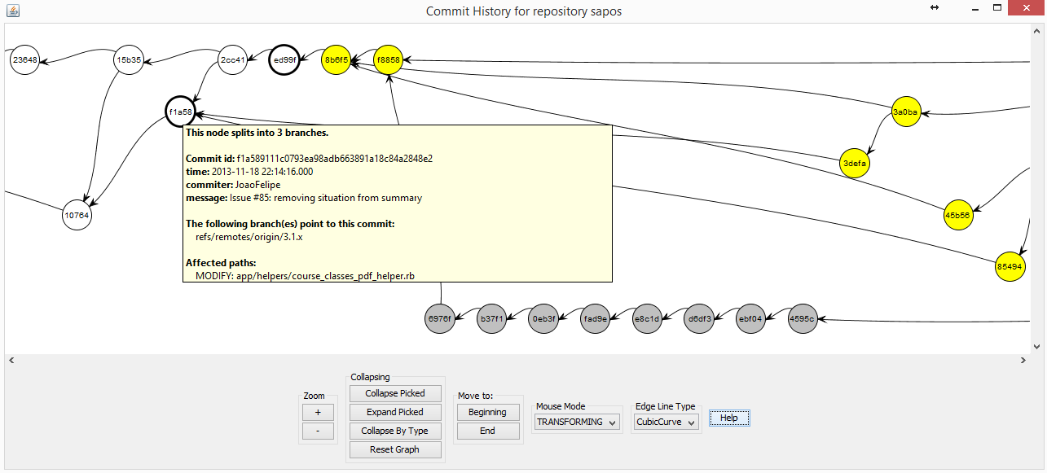

Figure 8 - Commit history for a given project

Commits are drawn according to their precedence order. Thus, if a commit N is created after a commit N – 1, then commit N will be located in the right hand side of commit N – 1. For each commit, DyeVC presents the information shown in Figure 3 (gathered from the central database), along with information that is read in real time from the repository metadata, such as branches that point to that commit and files that were affected by that commit (modified, deleted, inserted).

Each commit is painted according to its existence in the local repository and in the peers’ repositories. Ordinary commits that exist locally and in all peers are painted in white. Green commits are ready to be pushed, as they exist locally but do not exist in at least one of the peers in the push list. Yellow commits need attention because they exist in at least one peer in the pull list, but do not exist locally, meaning that they may be pulled. Red commits do not exist locally and are not available to be pulled, as they exist only in repositories that are not peers. Finally, gray commits exist locally, but belong to non-tracked branches, meaning that they can neither be pushed nor pulled.

There is also the possibility to collapse nodes to provide a better understanding of a large number of commits. As shown in Figure 9, the label of collapsed nodes show the number of contained nodes (there is a white node containing 118 nodes and a green node containing 24 nodes).

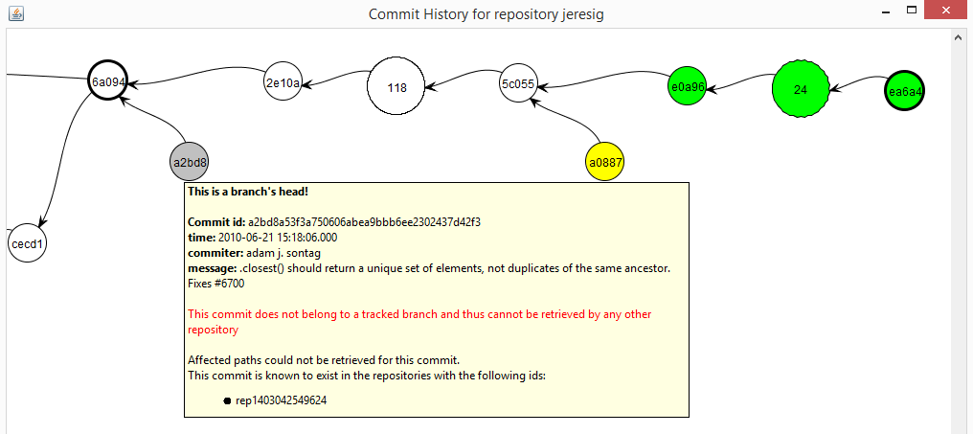

Figure 9 - Collapsed commit history

## Behind the Scenes

What DyeVC does behind the scenes involves depicting what are the existing repositories and commits in the topology. To update repository information, we follow the process represented by the activity diagram in Figure 10. This process is periodically triggered and it begins with a list of repositories being monitored. Each repository *rep* is inserted or updated in the database, where we keep track of each hostname that references them (either by monitoring, pushing to or pulling from). If the user has requested to stop monitoring *rep*, it will be marked for deletion, in which case the user’s machine is removed from *rep’s* *monitoredBy* set. Otherwise, the user’s machine is inserted in *rep’s monitoredBy* set. Next, we find which repositories *rep* pulls from and pushes to, by looking at *rep’s* configuration files, and we adjust the *pushesTo* and *pullsFrom* lists. The updates are sent to the central database, and the repositories that are no long referenced are deleted.

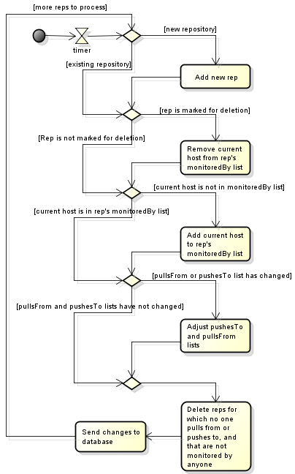

Figure 10 - Updating repositories in the topology

We use **Algorithm 1** to update commits in the topology. This update finds out the existing commits and depicts where they can be found. The whole process is based on the Set Theory and is executed for each repository *rep* being monitored by the user. The algorithm receives the repository being monitored (*rep*, a RepositoryInfo instance, the set of existing commits in the database (*db.commits*), the set of existing commits at *rep* on the previous monitoring cycle (*previousSnapshot*)and the set of existing commits at *rep* at the current monitoring cycle (*currentSnapshot*).

First of all, we subtract *currentSnapshot* from *previousSnapshot* to find *commitsToDelete*, that containscommits that were deleted since the previous monitoring cycle (line 2) and we delete them from the database (line 3). Conversely, we subtract *previousSnapshot* from *currentSnapshot to find newCommits*, which contains commits that are new in *rep* since the previous monitoring cycle (line 5).

Next, we find out which of *newCommits* will have to be inserted into the database, by subtracting the existing commits in the database (*db.commits*) from *newCommits* (line 6). Commits that will be updated are represented by *commitsToUpdate* (line 7) and they consist of those commits that exist in the database (), but were not found in at least one of the repositories related to *rep* on the last monitoring cycle . These commits must be verified because since the previous monitoring cycle it may happen that they now are found in other repositories related to *rep*.

**Algorithm 1:** Updating commits in the topology

**input**: a RepositoryInfo *rep* representing the repository being analyzed and three sets of CommitInfo *db.commits*, *previousSnapshot* and *currentSnapshot*.

1. **begin**
2. 
3. **delete** *commitsToDelete* ***from*** *database*
4. 
5. **
6. 
8. **foreach do**
9. updateFoundIn(*c, rep, currentSnapshot*)
10. **endfor**
11. **foreach** *c* ∈ *commitsToUpdate* **do**
12. updateFoundIn(*c, rep, currentSnapshot*)
13. **endfor**
14. **insert** *commitsToInsert* ***into*** *database*
15. **update** *commitsToUpdate* ***in*** *database*
16. 
17. **delete***orphanedCommits* ***from*** *database*
18. **end**
19. **procedure updateFoundIn**(*c: CommitInfo, rep: RepositoryInfo: Set of RepositoryInfo, currentSnapshot: Set of Commit*)
20. 
21. 
22. **if** *isBehind* **then**
23. 
24. **endif**
25. **if** *isAhead* **then**
26. 
27. **endif**
28. **if** ( **then**
29. **if**  **then**
30. ****
31. **else**
32. 
33. **if** *isTracked* **then**
34. 
35. **else**
36. 
37. **endif**
38. **endif**
39. **endif**
40. **end**

Commits to be inserted or updated must be verified to check where they exist, thus updating the *c.foundIn* attribute. This verification is done using the procedure *updateFoundIn* (lines 23-47), which is called in lines 9-15. This procedure finds out where each commit *c* exists based on its existence locally or in any repository in the push or pull sets. This procedure verifies if *rep* is ahead of any repository in its push list regarding *c* (line 24), i.e., if *c* exists () and if there is at least one repository that *rep* pushes to that does not contain *c* . Likewise, it verifies if *rep* is behind of any repository in its pull list regarding *c* (line 25), i.e., if *c* does not exist locally () and if there is at least one repository that *rep* pulls from that contains *c* . If *rep* is behind, than all repositories in *rep’s* pull list that contain *c* are added to *c*.*foundIn* (lines 27-29). If *rep* is ahead, than *rep* and all repositories in *rep’s* push list that contain *c* are added to *c.foundIn* list (lines 31-33). It may happen that *rep* is neither ahead nor behind any repository (line 35)*.* In such case, one of the following three scenarios may happen: In scenario 1, *c* does not exist in current snapshot (line 36), meaning that it also does not exist in any of the related repositories, thus we remove *rep* and all its related repositories from *c.foundIn* (line 37). For scenarios 2 and 3, we first depict if *c* is reachable from a tracked branch, i.e., if at least one of *rep.branches* is tracked and has *c* as one of its elements (line 39). In scenario 2, *c* is in a tracked branch, meaning that it also exists in all related repositories (remember that *rep* is neither ahead nor behind their partners), thus we include *rep* and all its related repositories in *c.foundIn* (line 41). Finally, in scenario 3, *c* is not in a tracked branch, meaning that it exists only in *rep*, thus we include only *rep* in *c.foundIn* (lines 43).

After updating where each commit is found, *commitsToInsert* is inserted into the database (line 17) and *commitsToUpdate* is updated in the database (line 18). Finally, it may happen that some commits end up with an empty *foundIn* attribute, meaning that they do not exist anywhere in the topology (line 19). These so-called *orphanedCommits* are then removed from the database (line 20) and the algorithm ends.

## Technologies Used

We implemented our approach as a Java Swing application (ELLIOTT *et al.*, 2002) launched by Java Web Start (MARINILLI, 2001) Technology. It currently monitors Git repositories, as it is the most used DVCS nowadays (ECLIPSE FOUNDATION, 2013). The source code and the link to download the tool via Java Web Start can be found at GitHub[[10]](#footnote-10). The application gathers information from repositories using JGit library (JGIT, 2014), which allows the user to use our approach without having a Git client installed. Information gathered is stored in a central document database running MongoDB (CHODOROW, 2013).

We hosted our database on a free MongoDB instance provided by MongoLab[[11]](#footnote-11). To prevent from firewall blocks when accessing the database, we did not use MongoDB proprietary API, which would demand opening specific ports to connect to MongoDB. Instead, we opted to use MongoLab’s RESTful (*Representational State Transfer*) API (*Application Programming Interface*). RESTful APIs (RICHARDSON; RUBY, 2013) have the advantage to be available using standard HTTP and HTTPS protocols. This way, our approach can be used easily from inside corporate and academic environments, without major problems. In order to use the RESTful API provided by MongoLab, we implemented a MongoLabProvider, responsible for translating the application methods into RESTful commands and vice-versa. This provider also serializes and deserializes the application objects to and from JSON (*JavaScript Object Notation*) (JSON, 2014)representations in order to send and receive them through the RESTful commands.

We present the information gathered as a series of graphs by using JUNG (*Java Universal Network/Graph Framework*) library (JUNG, 2010), from which it inherits the ability to extend existing layouts and filters to create new ones, which can be dynamically attached to the graphs that it presents.

All graphs present similar behavior, allowing the window to be zoomed in or out, whether the user wants to see details of a particular area or an overview of the entire graph. By changing the window mode from *transforming* to *picking*, it is possible to select a group of nodes and collapse them into one node, or simply drag them into new positions to have a better understanding of an area where there are too many crossing lines.

## DyeVC Usage

As we discussed in the previous section, DyeVC uses Java Web Start technology and thus does not need to be formally installed. After launching the application for the first time, it creates a shortcut in the Desktop (Figure 11.a), which can be used to execute the application later on. After running the application, it lies on the system tray bar (Figure 11.b). A single click on the icon will show the application window and minimizing it will take it back to the tray bar.

 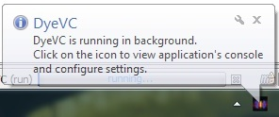

1. **(b)**

Figure 11 – DyeVC icon on the Desktop and on the tray bar

After maximizing the application, the main window is shown (Figure 12)

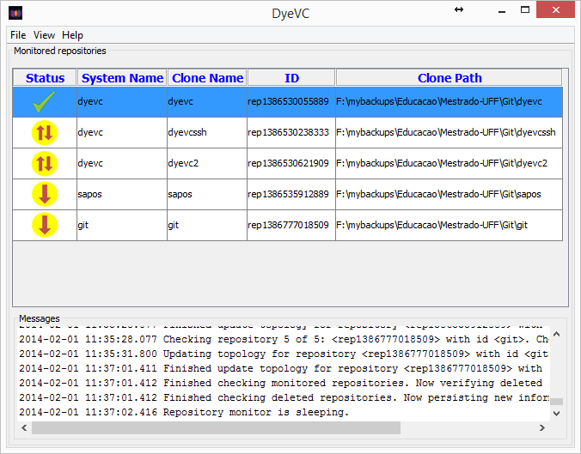

Figure 12 – DyeVC main window

The main window shows all monitored repositories, along with the following information in the Monitored Repositories panel:

* **Status**: An icon representing the clone status related to its known partners (as discussed in Section 1.3.3);
* **System Name**: The system or project name in which the clone belongs to. Clones that belong to the same project are shown together in the topology view;
* **Clone Name**: The name that the user gives to this particular clone. It must be unique on each single machine for a particular system name;
* **Id**: An internal unique id generated by DyeVC;
* **Clone Path**: The path in the local machine where this clone is found.

The application also shows relevant information regarding the monitoring status in the Messages panel. There is the possibility to see more detailed log messages by clicking on **View -> Console Window**. A new window will be opened, where messages are displayed according to their levels of criticality. The default behavior is to show INFO, WARN, and ERROR messages, but right clicking on the panel allows the user to change this behavior, allowing to also log TRACE and DEBUG messages.

The main screen will be initially empty as there is no repository being monitored. Clicking on **File -> Add Project** allows creating a new monitoring configuration (Figure 13). The user can choose a system name from the ones provided on the drop-down list, or type a new one, and click on the Explore button to choose the path where the clone is located. The Clone Name will be automatically chosen by the application, based on the folder name where the clone is located. For instance, if the user points the Clone Address to /home/users/username/myprojects/xyz, the Clone Name of this configuration will be xyz.

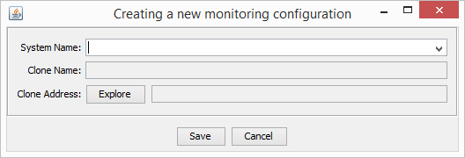

Figure 13 – Creating a new monitoring configuration

Once repositories are being monitored, the user is able to navigate through all the visualization levels discussed in Section 1.3, where each one of them is described, with examples. Level 1 (Notifications) will be shown as notifications in tray bar; Level 2 (Topology) will be presented by right clicking on a repository and choosing **Show Topology**; Level 3 (Tracked Branches) will be shown by hovering the mouse over any monitored repository; and Level 4 (Commits) will be accessible by right clicking on a repository and choosing **Show Commit History**.

## Final Considerations

In projects that use DVCS, there may be several clones where changes are being inserted simultaneously. These clones may communicate with each other indistinctively, turning the administration of such environment into a tough task. Today, administrators have no way to visualize the various clones and their dependencies, and developers have limited choices to provide awareness regarding parallel changes.

In this chapter, we presented the DyeVC approach, which supports the development and administration under DVCS environments, providing awareness in a non-obtrusive way, enabling administrators to visualize the repository topology and establishing an extensible platform to present information and metrics. We also discussed aspects of its implementation and usage.

The next chapter presents an experimental study to evaluate DyeVC in real projects.

# – evaluation

## Introduction

The purpose of this chapter is related to the research questions posed in <Include link to Introduction>:

* Q1: Which clones were created from a repository?
* Q2: What are the dependencies between different clones?
* Q3: Which changes are under work in parallel (in different clones or different branches) and which of them are available to be incorporated into my work?
* Q4: Is it computationally feasible to gather this information from all known repositories, keeping them available to be used when needed?

To assess the feasibility of our approach in answering these questions, we performed two experiments. First, we conducted a *post-hoc* analysis in a real project, to check if DyeVC can help answering questions Q1-Q3. Next, we took some real projects of different sizes and from different sources, in order to evaluate the scalability of our approach huge amounts of information using our approach, aiming at answering question Q4.

This chapter is organized as follows: Section 1.2 describes the *post-hoc* analysis experiment. Section 1.3 describes the performance evaluation of our approach. Section 1.4 discusses some threats to validity of the experiment. Lastly, Section 1.5 presents the final considerations of this chapter.

## Analyzing a real project with DyeVC

We conducted a *post-hoc* analysis using a real open source project to demonstrate that our approach can help answering questions Q1-Q3. We used the JQuery project[[12]](#footnote-12), a project that began in 2006 and had 6,222 commits by the time of the evaluation. We used the repository history and reconstructed it, simulating the actions that occurred in the past. We do not replicate the repository history here, due to its size, but the repository is public available at GitHub. We used comments generated automatically by Git to help us to depict specific flows that happened in the past. For example, the comment *“Merge branch 'master' of https://github.com/scottjehl/jquery into scottjehl-master”* tells us that there was a user named *scottjehl* and that the merge operation was done at a branch called *scottjehl-master* on that user’s repository.

Due to the operating mode of Git, some details are missing, but these do not compromise our analysis. The first one is the moment when a clone arises or deceases. This information does not exist anywhere in the repository. We inferred the creation of clones looking at the commit messages in the repository history (a commit by developer X led to the creation of a clone named X). Clones created at a given time stayed alive for the rest of the analysis.

The second missing detail is that although we had the commit dates and times in the repository history, these dates and times were not guaranteed to be correct. This is because in DVCS’s we do not have a central clock. Each commit is registered with the local time at the machine where the clone is located, which could lead us to have a commit in the history with a predecessor in the future, depending on when and where each one of them were performed. This missing detail is not so important, because the precedence between two commits is not depicted from their commit times, but from the pointers that Git maintains from a commit to its parents. We can use these dates, but not as an authoritative information.

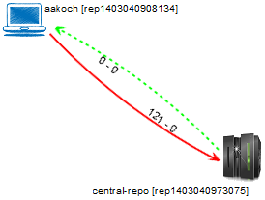

Figure 1 - Topology view showing first monitored repository (Sep 24 2010)

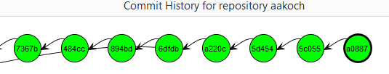

Figure 2 - aakoch’s commit history showing commits pending to be pushed

We chose a moment in time when three developers were involved, performing commits and merging changes in the repository. We created three clones for these developers, named after their author names and commit messages: *jeresig*, *adam*, and *aakosh*. Figure 1 shows the topology view on Sep 24 2010, when *aakosh* had 121 commits pending to be pushed to the central repository (hereafter represented as *central-repo*). Figure 2 shows part of aakosh’s commit history and how DyeVC represents commits pending to be pushed as green nodes in the graph.

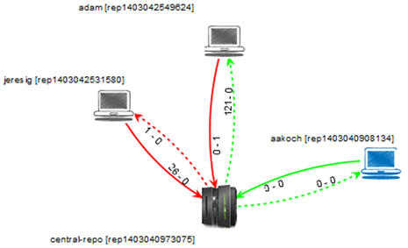

Figure 3 - Topology view showing the three monitored repositories (Sep 27 2010)

Later on, *aakoch* pushed his commits to *central-repo.* In the meantime, both *adam* and *jeresig* commited some changes. Before they pushed their work to *central-repo*, *adam’s* last commit had been done on Jun 21 2010 and *jeresig’s* on Sep 27 2010.At this moment, we registered them to be monitored by DyeVC. Figure 3 shows the topology view after this registration on Sep 27 2010. Here, we can see that *aakoch* was synchronized with *central-repo*, whereas *adam* and *jeresig* had some pending actions. At this point, we are able to revisit questions Q1 and Q2:

**Q1:** *Which clones were created from a repository?* DyeVC’s topology view (Figure 3) shows all the clones where there is an instance running, and discovers other clones connected to them, even if there is no instance running.

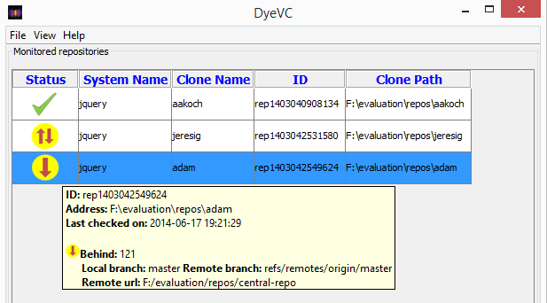

Figure 4 - Adam’s tracked branches

**Q2:** *What are the dependencies between different clones?* DyeVC’s topology view (Figure 3) shows the dependencies between the peers in the topology, as well as the number of commits ahead or behind in each of these dependencies.

*Adam* had 121 commits to pull from *central-repo*, what is corroborated by the details of his tracked branches (master branch in Figure 4). He also had a non-tracked commit pending to be pushed. Non-tracked commits are not shown in the tracked branches view, but we can see them in commit history views, painted in gray. Figure 5 shows the collapsed commit history for *jeresig*, where we can see *adam’s* non tracked commit with hash *a2bd8* (we know this is an *adam’s* commit by comparing the id of the repository in the message details with *adam’s* repository id in Figure 3).



Figure 5 – Jeresig’s collapsed commit history

The repository history leads us to think that *jeresig* is a core developer in the project, because he performed most of the merges to master branch. Looking at Figure 3, we see that he had 26 commits pending to be pushed to *central-repo*. These 26 commits can be seen at *aakoch’s* commit history (Figure 6), as red commits, once they could not be pulled by *aakoch* until *jeresig* pushed them to *central-repo*.There was also a commit in *central-repo* pending to be pulled by *jeresig*. If we look back at Figure 5 we see that the only yellow commit is *a0887*, made by *aakoch*. This tells us that *jeresig* pulled changes from *central-repo* at a moment before *aakoch* pushed commit *a0887*. If we look at Figure 7, we see that all pending commits (those that were pending to be pushed and those that were pending to be pulled) are related to the same branch *master*. This tells us that, if *jeresig* wanted to push these commits to *central-repo*, he would have to perform both push and pull operations. This analysis helps us revisit and answer Q3.

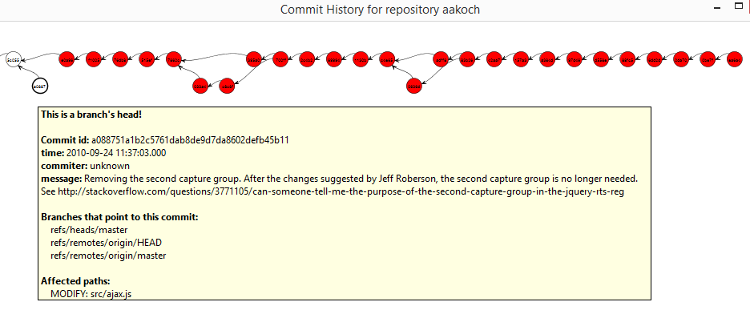

Figure 6 - Aakoch’s commit history

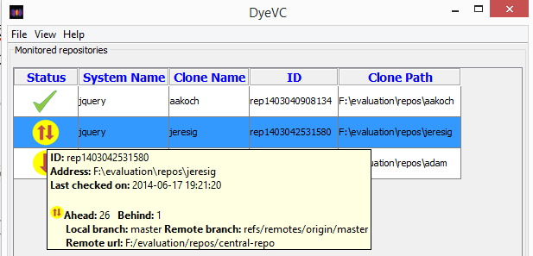

Figure 7 - Jeresig’s tracked branches

**Q3:** *Which changes are under work in parallel (in different clones or different branches) and which of them are available to be incorporated into my work?* New commits in tracked branches of peers can easily be found looking at Level 3 information (tracked branches, shown in Figure 4 and Figure 7). This view shows to which branch these commits are related and how many new commits exist. If we want to look at each commit individually, we can look at Level 4 information (commit history, shown in Figure 2 and Figure 6) and notice the yellow nodes. Additionally, Level 4 information is used to find new commits in repositories that are not peers (red nodes), or new commits in non-tracked branches (gray nodes).

## Performance evaluation

In order to evaluate the scalability of our approach, we evaluated the time spent to perform the most common DyeVC operations, by analyzing repositories of different sizes and hosted in different Git servers.

We measured the main operations of our approach: “Insert 1st”, invoked when the user includes the first repository of a given system to be monitored. “Insert 2nd”, invoked when the user includes a repository to be monitored in a system that already have registered repositories. “Commit History”, invoked when the user requests to see the commit history of a given repository. “Topology”, invoked when the user wants to see the topology of repositories of a given system. “Check Branches”, invoked periodically to check all the monitored repositories, searching for ahead or behind commits. “Update Topology”, invoked periodically to update the topology information in the central database. This last operation updates the existing repositories, their peers, and the existing commits, marking in which repositories each commit is found.

Table 1 shows the monitored projects (name and hosting service), the repository metrics – in terms of number of commits, disk usage, and number of files –, and the time spent by DyeVC to run some background and foreground operations. All measurements were done in the same period of the day and from the same machine, a Core Duo CPU running at 2.53 GHz, with 4GB RAM running Windows 8.1 Professional 64 bits, connected to the internet at 35 Mbit/s.

Table 1 – Scalability results of DyeVC for repositories with different metrics

|  |  |  |  |  |  |  |  |  |  |  |  |
| --- | --- | --- | --- | --- | --- | --- | --- | --- | --- | --- | --- |
|  |  | Repository metrics | | | Foreground operations | | | Background operations times (s) | | | |
| Repository | **Hosting** | ***# commits*** | ***Size (MB)*** | ***# files*** | ***Commit History*** | | ***Topology*** | ***Insert 1st*** | ***Insert 2nd*** | ***Check Branches*** | ***Update Topology*** |
| **Commit History** | ***Memory Usage[[13]](#footnote-13)*** | ***Time (s)*** |
| DyeVC | github.com | 187 | 1.0 | 539 | 3.5 | 15 | 2.7 | 12.4 | 16.1 | 1.7 | 4.4 |
| Sapos | github.com | 702 | 7.0 | 685 | 5.6 | 19 | 3.2 | 20.8 | 22.6 | 1.8 | 5.2 |
| jgit | eclipse.org | 2,979 | 10.0 | 1,595 | 18.4 | 512 | 3.4 | 42.4 | 46.0 | 5.9 | 6.8 |
| egit | eclipse.org | 3,775 | 27.0 | 1,478 | 21.3 | 559 | 3.7 | 49.6 | 46.6 | 4.2 | 7.3 |
| jquery | github.com | 5,518 | 20.0 | 253 | 65.0 | 1,121 | 4.1 | 40.0 | 37.4 | 1.4 | 9.4 |
| Tortoise Git | code.google.com | 6,166 | 85.0 | 3,220 | 68.0 | 492 | 4.2 | 39.0 | 36.0 | 1.6 | 9.6 |
| Gitextensions | github.com | 6,417 | 448.0 | 1,549 | 73.0 | 1,529 | 17.0 | 155.8 | 129.0 | 1.6 | 10.6 |
| drupal | drupal.org | 23,922 | 84.4 | 9,290 |  |  | 18.0 | 102.0 | 95.0 | 2.0 | 18.0 |
| Expresso Livre | gitorious.org | 25,822 | 141.0 | 20,729 |  |  | 18.2 | 110.0 | 102.0 | 2.1 | 19.3 |
| Git | github.com | 35,260 | 98.0 | 2,656 |  |  | 19.4 | 196.0 | 158.6 | 3.4 | 40.0 |

Table 2 - Pearson coefficient between measured operations and repository metrics

|  |  |  |  |
| --- | --- | --- | --- |
| Operation | # commits | Size | # files |
| Insert 1st | 0.79 | 0.65 | 0.30 |
| Insert 2nd | 0.82 | 0.65 | 0.36 |
| Check Branches | 0.00 | -0.28 | -0.13 |
| Update Topology | 0.94 | 0.17 | 0.33 |
| Commit History | 0.95 | 0.62 | 0.41 |
| Topology | 0.86 | 0.61 | 0.59 |

It is possible to notice that the “Commit History” operation has no values for the last three repositories. This occurs because, as the number of commits increases, more memory is used to calculate the commit history graph. The current algorithm has an *O(x2*) space complexity (*x* being the number of commits). The increasing memory usage is due to two factors: First, the commit graph has to be entirely in memory to be plotted. Second, the X position of nodes in the graph are calculated based on node ancestry, but the Y position is calculated in order to minimize the number of lines crossing during merges and splits in the graph. In order to do so, we used the *Dijkstra’s algorithm* (DIJKSTRA, 1959), for which memory usage also scales with the number of nodes. Our test machine was configured with a 2 GB maximum Java Heap Size, which let us analyze repositories with up to 6K commits. This is an aspect for future improvements. This analysis helps us to revisit and answer Q4.

**Q4:** *Is it computationally feasible to gather this information from all known repositories, keeping them available to be used when needed?* Yes. The current state of our approach allows one to gather information from repositories with up to 6K commits, up to 2GB of memory, in a reasonable time (the whole topology is shown in about 17 seconds). Increasing the amount of memory available or optimizing the algorithm are ways of allowing the approach to processes a higher number of commits.

Table 2 shows the correlation between each repository metric and the measured operations, according to the *Pearson coefficient* (PEARSON, 1895). This correlation coefficient measures the linear correlation between two variables X and Y and ranges from −1 to 1. Values of 1 or -1 mean that a linear equation can describe the correlation between X and Y perfectly (either positive or negative, respectively). A value of 0 means that there is no linear correlation between X and Y.

Looking at Table 2, we can see that the number of commits in the repositories is the metric with the Pearson coefficient nearest to 1. Generally, operations took longer in repositories that had more commits. Size also presents a high Pearson coefficient, but this is caused by the set of projects we chose, where the majority of repositories with a greater number of commits also had greater sizes. According to Table 1, the slowest operations were “Insert 1st” and “Insert 2nd”, due to the amount of data sent over the Internet to update the database. The only operation with no significant variation in response times was “Check Branches”. Amongst the foreground operations, the “Topology” operation had a significant increase in its response time, but with lower values than the “Commit History” operation. This is because the latter deals with much finer grain data than the former.

## Threats to Validity

While we have taken care to minimize threats to the validity of the experiment, some factors can influence the results. The usage of a *post-hoc* analysis to evaluate a real project may not reflect the exact real sequence of events that occurred, although the outcome did not change. For example, when we say that *aakosh*, at some moment, had 121 commits pending to be pushed to the central repository, these commits could have been pushed at once, or by a series of smaller pushes.

Moreover, only one project was selected to perform the *post-hoc* analysis, what imposes limitations from a statistical standpoint. Furthermore, there is a risk regarding the instrumentation used to measure the response times during the performance evaluation. As we used a database stored over the Internet, the response times may have been negatively affected by connectivity issues and network instability. The usage of a 35Mbit/s home network also contributes to this network instability, because home networks have much lower service level agreements than corporate ones.

Finally,we used an open source project to perform the *post-hoc* analysis. However, the *modus operandi* of peers in this context may be different from that of peers in academic or corporate contexts. Besides that, it is not possible to represent all different situations of a real project. We discussed the most common situations that occur when using DVCSs, but a more thoroughly verification is needed to evaluate the usefulness of our approach in other situations.

## Final Considerations

The evaluation of DyeVC aimed at identifying if the approach helps developers and administrators to work in projects that involve DVCS. We showed that DyeVC can provide the awareness regarding who are the people that work together on the same project and how they interact and / or depend on each other to accomplish their work. We also showed that it is feasible to gather information from different repositories, consolidating and showing it in a reasonable time.

In the next chapter, we present this work’s final considerations, describing our contributions, the limitations of the approach as well as future work.

# – Conclusion

## Contributions

This work introduced a new approach for DVCS monitoring and awareness, entitled *DyeVC*. This approach gathers information from registered DVCS clones and their peers, regarding the flow of communication and the existing commits in every node, and records this information in a central database.

The gathered information is consolidated, allowing developers to increase their knowledge of what is going on that might affect their work, as well as which changes have to be sent/received to/from their teammates. It also gives repository administrators the knowledge about which are the existing clones of a project and how they interact with each other.

*DyeVC* shows the information in different levels of detail, from a high-level topology-like visualization, where each node represents a repository clone, to a detailed level that presents every commit, despite the repository where it is located. Most of the visualizations use an extensible graph library that allows the approach to be extended through the creation of new visualizations and filters. The visualizations use transformations to present vertices and edges using different icons, colors, line types, and text labels, according to the characteristics that we want to highlight. This way, we established a framework for coupling different visualizations related to DVCS.

We have evaluated DyeVC on a real project, showing that it can be used to answer questions that arise when working with DVCSs. We have also evaluated DyeVC’s performance when used with repositories of different sizes, and we found out that the time and space complexity of the approach are directly related to the number of commits in the repository under analysis, especially in the view levels with finer granularity.

## Limitations

*DyeVC* has a scalability limitation, regarding processing performance and memory usage. We use the *Dijkstra* algorithm provided by the JUNG graph library to minimize the number of crossing lines in the lower level visualization (that shows each commit in the topology), and this procedure is not optimized to deal with graphs that contain thousands of nodes, although the high level topology visualization can be used on repositories with many thousands of commits.

Another limitation is related to the need of a central database to record information gathered from the several *DyeVC* instances. Although this central database is needed, we used a document-based database that is hosted free in the Internet, and the information is read and written using semi-structured JSON documents, that are automatically mapped to/from the application class model.

The need of a central database brings another limitation in the current implementation, regarding to security. The connection with the central database is authenticated by using an application key that is stored in the application itself. This way, different projects from different organizations will have their data gathered and stored in the same database. Although we do not store any sensitive information (we do not store contents of any files or commits, just metadata), this might be a concern for some people. We have plans to create different adapters, for example, to store the gathered information in local databases, with a per user authentication.

## Future work

The advent of *DyeVC* approach brings with it a number of possibilities for future researches. The following paragraphs describe possible improvements and researches that can be explored in the future.

The first improvement is related to the visualizations the approach already provides. Level 4 visualization, which shows every commit in the topology, could be enhanced with automatic collapsing of similar nodes. Currently, each vertex in level 4 visualization represents a single commit. Depending on the repository size, this leads to a graph that is very long horizontally, because we show each commit on a different X-coordinate, to give the idea of elapsed time. Even with the zooming feature, large repositories can be difficult to analyze. It happens that we normally want to analyze the very ending part of a repository, which comprises of the most recent commits in the topology, because the older ones probably were spread to the whole topology already. The current implementation has a feature for the user to select a group of commits and manually collapsing them, creating a single node that represents the group of collapsed commits, which is placed at the midpoint between the first and the last collapsed nodes. However, on a repository with thousands of commits, this is not very practical. Automatic collapsing could compact the visualization, by collapsing contiguous nodes that represent commits with the same level of accessibility, leaving only branch heads expanded.

Another possible improvement related to level 4 information is to attach filters and transformations to help answering a number of user questions, such as: Which repositories or people changed a specific artifact or group of artifacts? Which commits introduced the higher amount of changes in the code? Who were the top contributors in the project this week?

By increasing the amount of metadata that *DyeVC* already gathers, a number of research options arise. For example, supposing that we are dealing with text artifacts, if *DyeVC* gathers the changes introduced by each commit at the line level (by storing each commit’s *diff*), one could create a visualization to show conflicts that would happen when merging two branches.

Another area demanding work is related to scalability. Currently, all vertex and edges must be loaded into memory in order to calculate vertices positions when drawing level 4 information. Besides that, for repositories with a large number of commits, more than a minute is spent to calculate positions and draw the graph. The usage of automatically collapsing could help in terms of time spent to draw the graph, as there would be less vertices and edges to be plot, but the memory issue would be still be present, because the collapsed nodes would be still loaded into memory. A possible way to solve that would be to filter commits before plotting them, for example showing only commits performed this month. A downside of this approach is that it could lead to a disconnected graph, for example, if work has been done over this month on two separate branches whose common ancestor is a commit performed a long time ago, we would see two parallel sequence of commits, with no common ancestor.

A possible improvement in Level 2 visualization (which shows the topology) is regarding how the approach registers existing clones. In this visualization, once registered, clones will be presented forever. It might be the case that one had just registered a clone with *DyeVC* and never worked on it again. After some time, this could lead to a polluted topology view, with lots of “garbage”, i.e. repositories that are not used or that might not even exist. The approach could check when was the last change in each clone, marking those clones that did not change for a period time, so that an administrator could remove it from the topology. Similarly, an administrator could manually include nodes in the topology, to represent clones located in places with no *DyeVC* instance running, in order to complete the topology not previously seen by the approach.

Bibliography

APPLETON, B.; BERCZUK, S.; CABRERA, R.; ORENSTEIN, R. Streamed lines: Branching patterns for parallel software development. In: PATTERN LANGUAGES OF PROGRAMS CONFERENCE (PLOP 98), Aug. 1998, Monticello, Illinois, USA: ACM, Aug. 1998.

BATTIN, R. D.; CROCKER, R.; KREIDLER, J.; SUBRAMANIAN, K. Leveraging resources in global software development. *IEEE Software*, v. 18, n. 2, p. 70–77, Mar. 2001.

BIEHL, J. T.; CZERWINSKI, M.; SMITH, G.; ROBERTSON, G. G. FASTDash: A Visual Dashboard for Fostering Awareness in Software Teams. In: ACM CONFERENCE ON HUMAN FACTORS IN COMPUTING SYSTEMS (CHI ’07), May 2007, New York, NY, USA: ACM, May 2007. p. 1313–1322.

BRUN, Y.; HOLMES, R.; ERNST, M. D.; NOTKIN, D. Proactive detection of collaboration conflicts. In: ACM SIGSOFT SYMPOSIUM AND EUROPEAN CONFERENCE ON FOUNDATIONS OF SOFTWARE ENGINEERING (ESEC/FSE’11), Sep. 2011, New York, NY, USA: ACM, Sep. 2011. p. 168–178.

CEDERQVIST, P. *Version Management with CVS*. [N.A.]: Free Software Foundation, 2005.

CESARIO, C. M.; MURTA, L. G. P. What is going on around my repository? In: BRAZILIAN WORKSHOP ON SOFTWARE VISUALIZATION, EVOLUTION AND MAINTENANCE (VEM’13), 29 Sep. 2013, Brasilia, Brazil: UNB, 29 Sep. 2013. p. 14–21.

CHACON, S. *Pro Git*. 1. ed. Berkeley, CA, USA: Apress, 2009.

CHODOROW, K. *MongoDB: The Definitive Guide*. Second Edition edition ed. Beijing: O’Reilly Media, 2013.

COLLBERG, C.; KOBOUROV, S.; NAGRA, J.; PITTS, J.; WAMPLER, K. A System for Graph-based Visualization of the Evolution of Software. In: ACM SYMPOSIUM ON SOFTWARE VISUALIZATION (SOFTVIS ’03), Jun. 2003, New York, NY, USA: ACM, Jun. 2003. p. 77–ff.

COLLINS-SUSSMAN, B.; FITZPATRICK, B. W.; PILATO, C. M. *Version Control with Subversion*. Stanford, CA, USA: Compiled from r4849, 2011.

DA SILVA, I. A.; CHEN, P. H.; VAN DER WESTHUIZEN, C.; RIPLEY, R. M.; VAN DER HOEK, A. Lighthouse: coordination through emerging design. In: WORKSHOP ON ECLIPSE TECHNOLOGY EXCHANGE (OOPSLA ’06), Oct. 2006, New York, NY, USA: ACM, Oct. 2006. p. 11–15.

DEWAN, P.; HEGDE, R. Semi-synchronous conflict detection and resolution in asynchronous software development. In: EUROPEAN CONFERENCE ON COMPUTER-SUPPORTED COOPERATIVE WORK (ECSCW ’07), Sep. 2007, Limerick, Ireland: Springer London, Sep. 2007. p. 159–178.

DIEHL, S. *Software Visualization: Visualizing the Structure, Behaviour, and Evolution of Software*. 2007 edition ed. Berlin ; New York: Springer, 2007.

DIJKSTRA, E. W. A note on two problems in connexion with graphs. *Numerische Mathematik*, v. 1, n. 1, p. 269–271, 1 Dec. 1959.

DONG, J.; GANG, X. A Topology Discovery Algorithm Based on the IP-Network. In: 2012 INTERNATIONAL CONFERENCE ON CONTROL ENGINEERING AND COMMUNICATION TECHNOLOGY (ICCECT’12), Dec. 2012, Shenyang, Liaoning, China: IEEE, Dec. 2012. p. 665–668.

DOURISH, P.; BELLOTTI, V. Awareness and Coordination in Shared Workspaces. In: ACM CONFERENCE ON COMPUTER-SUPPORTED COOPERATIVE WORK (CSCW ’92), Nov. 1992, New York, NY, USA: ACM, Nov. 1992. p. 107–114.

ECLIPSE FOUNDATION. *The Open Source Developer Report - 2013 Eclipse Community Survey*. Survey. San Francisco, CA, USA: Eclipse Foundation, Jun. 2013.

ELLIOTT, J.; ECKSTEIN, R.; LOY, M.; COLE, B. *Java Swing, Second Edition*. 2nd edition ed. Sebastopol, CA: O’Reilly Media, 2002.

ELSEN, S. VisGi: Visualizing Git branches. In: IEEE WORKING CONFERENCE ON SOFTWARE VISUALIZATION (VISSOFT’13), Sep. 2013, Eindhoven, Netherlands: IEEE, Sep. 2013. p. 1–4.

ESTUBLIER, J. Software configuration management: a roadmap. In: INTERNATION CONFERENCE ON SOFTWARE ENGINEERING (ICSE ’00), May 2000, New York, NY, USA: ACM, May 2000. p. 279–289.

FITZPATRICK, G.; MARSHALL, P.; PHILLIPS, A. CVS Integration with Notification and Chat: Lightweight Software Team Collaboration. In: ACM CONFERENCE ON COMPUTER-SUPPORTED COOPERATIVE WORK (CSCW ’06), Nov. 2006, New York, NY, USA: ACM, Nov. 2006. p. 49–58. . Accessed: 24 jun. 2014.

FUKS, H.; RAPOSO, A.; GEROSA, M. A.; PIMENTEL, M.; LUCENA, C. J. The 3c collaboration model. In: KOCK, N. (Org.). . *The Encyclopedia of E-Collaboration*. New York, NY, USA: Information Science Reference, 2007. p. 637–644.

GILBERT, E.; KARAHALIOS, K. LifeSource: Two CVS Visualizations. In: ACM CONFERENCE ON HUMAN FACTORS IN COMPUTING SYSTEMS (CHI ’06), Apr. 2006, New York, NY, USA: ACM, Apr. 2006. p. 791–796. . Accessed: 4 may 2014.

GOODMAN, L. A. Snowball Sampling. *The Annals of Mathematical Statistics*, MR: MR124140Zbl: 0099.14203, v. 32, n. 1, p. 148–170, Mar. 1961.

GUIMARÃES, M. L.; SILVA, A. R. Improving early detection of software merge conflicts. In: INTERNATION CONFERENCE ON SOFTWARE ENGINEERING (ICSE ’12), Jun. 2012, Piscataway, NJ, USA: IEEE Press, Jun. 2012. p. 342–352.

GUMM, D.-C. Distribution Dimensions in Software Development Projects: A Taxonomy. *IEEE Software*, v. 23, n. 5, p. 45–51, Sep. 2006.

GUTWIN, C.; GREENBERG, S.; ROSEMAN, M. Workspace Awareness in Real-Time Distributed Groupware: Framework, Widgets, and Evaluation - Springer. In: SASSE, M. A.; CUNNINGHAM, R. J.; WINDER, R. L. (Org.). . *People and Computers XI*. London: Springer London, 1996. p. 281–298. . Accessed: 22 jun. 2014.

HOZUMI, T. *Visugit*. Available at: <https://github.com/hozumi/visugit>. Accessed: 2 jan. 2015.

IEEE. IEEE Standard for Configuration Management in Systems and Software Engineering. *IEEE Std 828-2012 (Revision of IEEE Std 828-2005)*, p. 1–71, Mar. 2012.

JGIT. *JGit Project Homepage*. Available at: <http://www.eclipse.org/jgit/>. Accessed: 2 jan. 2015.

JSON. *JSON Homepage*. Available at: <http://json.org/>. Accessed: 2 jan. 2015.

JUNG. *JUNG Homepage*. Available at: <http://jung.sourceforge.net/>. Accessed: 2 jan. 2015.

LANZA, M. The Evolution Matrix: Recovering Software Evolution Using Software Visualization Techniques. In: INTERNATIONAL WORKSHOP ON PRINCIPLES OF SOFTWARE EVOLUTION (IWPSE ’01), Sep. 2001, New York, NY, USA: ACM, Sep. 2001. p. 37–42.

LEON, A. *Software Configuration Management Handbook, Second Edition*. 2. ed. Norwood, MA, USA: Artech House, 2004.

LI, H.; DAN, C.; HUAIXIANG, B.; SHURONG, L. Topology Discovery Algorithm Based on Ant Colony Algorithm of Power Line Carrier Sensor Network. In: INTERNATIONAL CONFERENCE ON COMMUNICATION SOFTWARE AND NETWORKS (ICCSN ’09), Feb. 2009, Macau, China: IEEE, Feb. 2009. p. 102–105.

LI, M.; YANG, J.; AN, C.; LI, C.; LI, F. IPv6 network topology discovery method based on novel graph mapping algorithms. In: IEEE SYMPOSIUM ON COMPUTERS AND COMMUNICATIONS (ISCC ’13), Jul. 2013, Split, Croatia: IEEE, Jul. 2013. p. 000554–000560.

MARINILLI, M. *Java Deployment with JNLP and WebStart*. 1 edition ed. Indianapolis, Ind: Sams Publishing, 2001.

MURTA, L. G. P. *Gerência de Configuração no Desenvolvimento Baseado em Componentes*. 2006. 213 f. UFRJ, COPPE, Rio de Janeiro, Brasil, 2006.

O’SULLIVAN, B. Making sense of revision-control systems. *Communications of the ACM*, v. 52, n. 9, p. 56–62, Sep. 2009a.

O’SULLIVAN, B. *Mercurial: The Definitive Guide*. 1. ed. Sebastopol, CA, USA: O’Reilly Media, 2009b.

PEARSON, K. Note on Regression and Inheritance in the Case of Two Parents. *Proceedings of the Royal Society of London*, v. 58, n. 347-352, p. 240–242, 1 Jan. 1895. Accessed: 22 jun. 2014.

PERRY, D. E.; SIY, H. P.; VOTTA, L. G. Parallel changes in large scale software development: an observational case study. In: INTERNATIONAL CONFERENCE ON SOFTWARE ENGINEERING (ICSE 98’), Apr. 1998, Washington, DC, USA: IEEE Computer Society, Apr. 1998. p. 251–260.

PRESTON-WERNER, T. *GitHub’s Network Graph*. Available at: <https://github.com/blog/39-say-hello-to-the-network-graph-visualizer>. Accessed: 2 jan. 2015.

RICHARDSON, L.; RUBY, S. *RESTful Web APIs*. 1 edition ed. Sebastopol, Calif.: O’Reilly Media, 2013.

ROCHKIND, M. J. The source code control system. *IEEE Transactions on Software Engineering. (TSE)*, v. 1, n. 4, p. 364–470, Dec. 1975.

SARMA, A.; REDMILES, D. F.; VAN DER HOEK, A. Palantir: Early Detection of Development Conflicts Arising from Parallel Code Changes. *IEEE Transactions on Software Engineering*, v. 38, n. 4, p. 889 –908, Aug. 2012.

SCHOLLMEIER, R. A definition of peer-to-peer networking for the classification of peer-to-peer architectures and applications. In: INTERNATIONAL CONFERENCE ON PEER-TO-PEER COMPUTING (P2P’01), Aug. 2001, Linkoping, Sweden: IEEE, Aug. 2001. p. 101–102.

STEINMACHER, I.; CHAVES, A.; GEROSA, M. Awareness Support in Distributed Software Development: A Systematic Review and Mapping of the Literature. *15th ACM Conference on Computer-supported Cooperative Work (CSCW ’12)*, p. 1–46, May 2012.

TICHY, W. RCS: A system for version control. *Software - Practice and Experience*, v. 15, n. 7, p. 637–654, 1985.

UZAIR, U.; AHMAD, H. F.; ALI, A.; SUGURI, H. An Efficient Algorithm for Ethernet Topology Discovery in Large Multi-subnet Networks. In: IEEE INTERNATIONAL CONFERENCE ON SYSTEM OF SYSTEMS ENGINEERING (SOSE ’07), Apr. 2007, San Antonio, TX, USA: IEEE, Apr. 2007. p. 1–7.

VOINEA, L.; TELEA, A.; VAN WIJK, J. J. CVSscan: Visualization of Code Evolution. In: ACM SYMPOSIUM ON SOFTWARE VISUALIZATION (SOFTVIS ’05), May 2005, New York, NY, USA: ACM, May 2005. p. 47–56.

WALRAD, C.; STROM, D. The importance of branching models in SCM. *IEEE Computer*, v. 35, n. 9, p. 31 – 38, Sep. 2002.

YAN, H. The study on network topology discovery algorithm based on SNMP protocol and ICMP protocol. In: INTERNATIONAL CONFERENCE ON SOFTWARE ENGINEERING AND SERVICE SCIENCE (ICSESS ’12), Jun. 2012, Beijing, China: IEEE, Jun. 2012. p. 665–668.

YONG, W.; NAN, P.; XIAOLING, T. Network topology discovery algorithm based on OSPF. In: INTERNATIONAL CONFERENCE ON INTELLIGENT COMPUTING AND INTEGRATED SYSTEMS (ICISS ’10), Oct. 2010, Guilin, China: IEEE, Oct. 2010. p. 136–139.

1. Dye is commonly used in cells to observe the cell division process. As an analogy, DyeVC allows developers to observe how a Version Control repository evolved over time. [↑](#footnote-ref-1)
2. Here we focus on the possibility of breaking a *pull* into two different commands, but keep in mind that different tools can have different commands to do the same operation. An example is the *pull* command. Whereas in *Git* it brings the changes and applies them to the workspace, in *Mercurial* it only brings the changes and we have to perform an *update* command to apply them. Later versions of *Mercurial* are being distributed with a *fetch* extension, which brings the changes and applies them. This way, the *pull* command in *Git* is equivalent to the *fetch* command in *Mercurial*, and vice-versa. Whenever we mention any command herein, we will be expecting the behavior provided by *Git*. [↑](#footnote-ref-2)
3. A compilation of branching patterns to address different needs can be found in (APPLETON *et al.*, 1998). [↑](#footnote-ref-3)
4. http://svnnotifier.tigris.org/ (2012) [↑](#footnote-ref-4)
5. https://github.com/pocorall/scm-notifier (2012) [↑](#footnote-ref-5)
6. http://tools.tortoisesvn.net/CommitMonitor.html (2013) [↑](#footnote-ref-6)
7. http://code.google.com/p/svnradar/ (2011) [↑](#footnote-ref-7)
8. http://www.fsmpi.uni-bayreuth.de/~dun3/hg-commit-monitor (2009) [↑](#footnote-ref-8)
9. http://www.visualstudio.com/en-us/products/tfs-overview-vs.aspx (2013) [↑](#footnote-ref-9)
10. https://github.com/gems-uff/dyevc [↑](#footnote-ref-10)
11. http://mongolab.com [↑](#footnote-ref-11)
12. https://github.com/jquery/jquery.git [↑](#footnote-ref-12)
13. Memory usage was measured in MB during the execution of “Commit History” operation. [↑](#footnote-ref-13)